**P2556958**

**De Montfort University**

**IMAT5314 Project**

**MSc Information Systems Management**

# **Abstract**

An Exclusive Website for

‘Damao Jetty’

takeaway Restaurant Business.

In today’s business there are many booming restaurant websites which primarily focused for dine-in and takeaway. But there are very less websites for the small restaurant like which include only a takeaway service. However, the Damao Jetty restaurant is known for its very famous variety of food items. This Damao Jetty website includes many features like sliding of images, playing a video having a gallery of images, displays the customer order status, admin can view customer’s orders and update the, admin can add/edit/delete the food items, sends invoice to the customer via email and allows the customer to make different types of payment method.

The main aim of this project is to implement a website which interact with the customers and allow them to place food order, check their order status and many options for the admin of the business to work with. This report contains the implementation of ‘Damao Jetty’ website which covers project development execution, planning, project management, and project development analysis.

# **Acknowledgements**

I have obtained valuable support from De Montfort University and my supervisor Martin Kenneth Stacey during the study of my research.

I take this opportunity to thank De Montfort University for offering me with the resources and materials for the implementation of the project. I also would like to thank my family members who have supported me during my educational growth.

Finally, I would also like to thank professor Martin Kenneth Stacey for his helpful and positive feedback throughout this project work planning and management. His ability to so kindly give his time has been hugely appreciated.

**Table of Contents**

**Abstract** 1

**Acknowledgements** 2

**1.** **Chapter One: Introduction** 7

1.1 Overview of the Project 7

1.2 Project Motivation 8

**2.** **Chapter Two: Background and Related Research** 9

2.1 Background 9

2.2 Literature Review and Research Questions 10

2.2.1 What frameworks are used to implement a successful website? 12

2.2.2 How can a website be implemented by using the ASP.NET MVC (Model View Controller) technology? 14

2.2.3 How communication and good understanding between you and client can make you build a good website? 17

2.2.4 How a web-designs is important for the website? 20

2.2.5 How data warehouse or a database can be designed for the project in MS SQL? 22

2.2.6 What are the methods and system to improve security of website? 24

2.2.7 How can you link website quality with customer loyalty? 26

**3.** **Chapter Three: Research Methodology** 28

3.1 Qualitative Research & Quantitative Research Methods 28

3.2 Data Generation Methods 29

3.2.1 Interview’s 29

3.2.2 Surveys & Questionnaires 30

3.2.3 Focus Groups 31

**4.** **Chapter Four: Design Consideration** 32

4.1 User Interface Design (UI Design) 32

4.3 Class Diagram 33

4.4 Gantt chart 33

4.5 MVC Design Pattern 34

4.6 Web Forms 34

4.7 New concept Learned 34

**5.** **Chapter Five: Requirement Analysis** 38

5.1 System Requirements 38

5.2 Hardware Requirements, Constraints & Needs 39

5.3 Use Cases 40

**6.** **Chapter Six: Implementation** 45

6.1 Tools and Languages used 45

6.1.1 C# Language 45

6.1.2 CSS (Cascading Style Sheets) 46

6.1.3 HTML (Hypertext Mark-up Language) 46

6.1.4 SQL (Structured Query Language) 46

6.1.5 MS SQL Server 46

6.1.6 Visual Studio 47

6.1.7 GitHub 47

6.2 Database Implementation 47

6.3 Webpages Implementation 48

6.3.1 Home Page 48

6.3.2 Menu Page 49

6.3.3 About Us Page 49

6.3.4 Gallery Page 49

6.3.5 Contact Us Page 50

6.3.6 Order Status Page 50

6.3.7 Cart Page 50

6.3.8 Payment Page 51

6.3.9 Login 51

6.3.10 Admin Page 52

6.3.11 Add Food Item Page 52

6.3.12 Edit Food Item Page 53

6.3.13 Update Order Status Page 53

**7.** **Chapter Seven: Evaluation** 53

7.1 Product Evaluation 53

7.2 Approach 54

7.3 Tools Evaluation 55

**8.** **Chapter Eight: Conclusion & Recommendation** 55

8.1 Conclusion 55

**9.** **Reference** 57

**10.** **Appendices** 61

10.1 Appendix 1 - UI Diagrams (User Interface) 61

10.2 Appendix 2 - ERD Diagram 66

10.3 Appendix 3 - Class Diagram 67

10.4 Appendix 4 - Use Case Diagram 68

10.5 Appendix 5 – Requirements 69

10.6 Appendix 6 – Database Implementation 70

10.6.1 Database Structure 70

10.6.2 Customer Table 71

10.6.3 Order Table 72

10.6.4 Food Items Table 73

10.6.5 Payment Table 74

10.6.6 Order Details Table 75

10.6.7 Order Status Table 76

10.6.8 Card Payment Table 77

10.6.9 Cash on Collection Table 77

10.7 Appendix 7 – Web Pages Implemented 78

10.7.1 Home Page 78

10.7.2 Menu Page 79

10.7.3 About Page 80

10.7.4 Gallery Page 81

10.7.5 Contact Page 82

10.7.6 Order Status Page 83

10.7.7 Cart Page 84

10.7.8 Payment Page 85

10.7.9 Login Page 86

10.7.10 Admin View Page(Add/Edit/Remove Menu Items) 87

10.7.11 Add Food Item Page 88

10.7.12 Edit Food Item Page 89

10.7.13 Order Status Update Page 90

**11.** **Progress Reports** 91

11.1 Report - 1 91

11.2 Report - 2 92

11.3 Report - 3 93

11.4 Report - 4 94

**12.** **GitHub Logs** 95

**13.** **Gantt Chart** 96

**Table of Figures**

Figure 1 - Store Procedure 8

Figure 2 - Customer Form 8

Figure 3 - Frameworks Implementation 13

Figure 4 - MVC Technology 15

Figure 5 - MVC Framework 16

Figure 6 - Good Communication 19

Figure 7 - Web Designs 21

Figure 8 - Datawarehouse Design 23

Figure 9 - N-tire MVC 35

Figure 10 - Presentation Layer 36

Figure 11 – Framework 37

**List of Tables**

Table 1 - Strength & Weakness of MVC 16

Table 2 - Advantages & Dis-advantages of Web Designs 21

Table 3 - Pro’s & Cons of MVC Framework 37

Table 4 - Key Attributes 47

# **Chapter One: Introduction**

## 1.1 Overview of the Project

This website is a .Net Web Application implemented for online food ordering system and to flow the processes easily called "Damao Jetty". Today almost all the restaurants have their own websites to manage their business flow but there are very less restaurant’s which are small in size of business and provide only takeaway service which does not have any websites for their business. This website will help the business owner to run their business very smoothly by processing orders through a system and avoiding the phone orders.

The main objective of this website is to store and retrieve the data from the database, for example this website stores the details of the customer, stores the details of payment, stores the orders of customer and it also retrieve the order status for the customer’s order. It also has a contact section where the customer can include some comment or provide some feedback and then on a button click the owner receives the information via email.

This website is mainly developed for the customers and every individual who can access the website globally. Throughout this circumstance to access the website, individuals would not require to sign in to the web application but in the case of the Admin needs to login into website admin page which will allow him to change/edit the contents of the website.

In this project the forms were implemented (Figure 1) to allow the customer to enter the data so that the data can be stored and retrieved through the database in the web application. How this works? When the customer fills out all the details in the form and press on any action button it stores the information into the database and this is done by writing a ‘Store Procedure’ query in database.

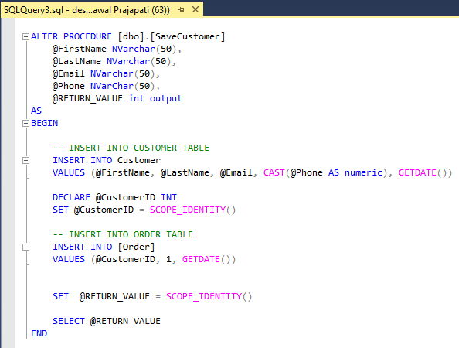

Figure - Store Procedure

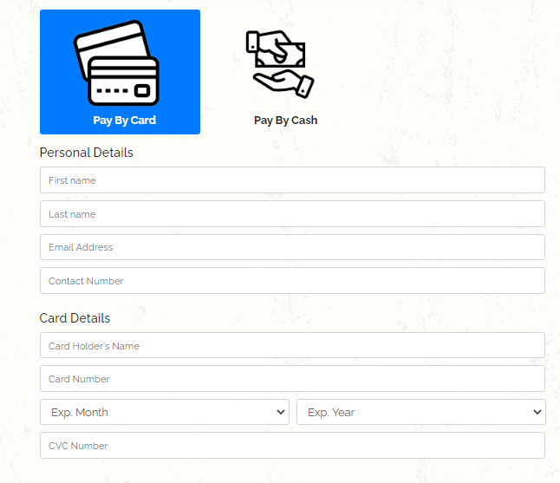

Figure - Customer Form

## 1.2 Project Motivation

The main motivation in this project for me was to learn something new and gain as much as deep knowledge. I've studied many facets of the methods for project development and implementation. Many tools and languages like C#, MVC .Net framework, HTML, CSS stylesheet, JavaScript and MSSQL were undertaken while project implementation to gain knowledge. The biggest motivation for me was to gain deep knowledge in frontend which was very challenging throughout this project. I believe that my hard work, my motivation and things what I have learnt in this project will lead me to a professional web developer/full stack developer in future.

# **Chapter Two: Background and Related Research**

## 2.1 Background

Today the restaurant business is the most challenging business in the world. The biggest concern for business owners of the restaurant is to face one of the major issues like managing orders over the phone or in-person (Daries et al., 2018). Delay in delivering orders, mis-match order deliveries, this may lead to bring big loss in the business and customer dissatisfaction. The expectation of the customers is to have good quality of food, good taste and good customer service which is not always the case. There has been a lack of technology and solutions in place to manage and handle the above concerns.

When used alongside revenue management concepts, effective technology will help restaurants of all types increase sales and benefit (Kimes, 2008). This project looks at how things can make easy for customers by introducing a good restaurant business website or application. In this project the implementation of the website includes different types of pages like Home page, Menu page, about us page, contact page and the Cart page where customers can visit the website and order the food online, also customers can add feedback to the restaurant through the website.

In this day and age, the organisational problems at restaurants have a lot to do with automation. It makes the restaurant issues and their solutions for small businesses more difficult. Most restaurant issues are caused by taking orders online. However, these problems can be solved by introducing an online ordering programme on the restaurant website , making the order button clearly visible and tailored for the smartphone (Miranda, Rubio and Chamorro, 2015). This website will be facing the issues by providing a good view of the website to the customers and giving easy navigation of the website to select the appropriate services of the website. There will be many different kinds of pages in website including a menu page where all the food item will be displayed with their price and with detailed description.

This website/application of the restaurant will allow the customer to order the food item online through the website, once the order is placed the customer will get the email notifying the order confirmation and once the order is completed by the restaurant the customer will get an alert on their mobile stating the order is now completed and ready for collection. This will help the customers to keep track of their orders once they have placed. The application will also allow the customer to make a secure payment online after once the customer has placed the order of food item.

## 2.2 Literature Review and Research Questions

A big issue (Ph.D and Borovicka, 2007) for many restaurant owners is that their standards for the launch of a website are Almost always unacknowledged, and their investment benefits mystify them. It is not commonplace to consider how prospective customers arrive at an impression of a restaurant company via a visit to its Website. Restaurant owners were described as being part of a sector Is slow to understand the power of websites which can exert as an instrument for boost or subtract from a company's profile (Ph.D and Borovicka, 2007).

A website is something which allows the restaurant owners to greet the quality of the websites from customer point of view which will promote the preparation and deployment of quality sites which is achievable advantage for the business. Thus, it is essential that the software is straightforward, simple to understand and to implement, and should help the website owner's capacity to take successful charge of the Website smoothly, even if the owner lacks the technological skills to make the changes personally (Bennett, 2017). Most consumers are searching for online guides and social media knowledge about restaurants. Restaurant websites especially include customer feedback that differ in quality and reflectivity. Online contact brings not only obligations relating to trust and partnerships, but also harmful impacts such as consumer deceptions and allegations. While, companies also benefit from this approach advertising in the areas of brand placement, product development and the development of customer value (Qi, Yang and Li, 2013). Websites for restaurant reviews help operators assess their internet activity, recognize their solutions and offer measures on complaints from customers.

In 1994 the Web reached community popularity. In less than two years, many restaurants moved to develop websites and were motivated to consider the new platform as a mediator to redefine the relationship between restaurant owner and consumer (Ph.D and Borovicka, 2007). The scholars of this early research managed to draw up a list of support function on restaurant websites such as email contact, group catering opportunities, booking services and attractive schemes and indicated that web marketing might become a technical requirement rather than an ability. As information technology has introduced a better way of communicating person-to - person, restaurant owners have the space to enhance competitors dominance not only by offering users with the precise data they need when they need it, but also by offering extra venues through which customers can interact with the restaurant owner (Young Namkung MS, Seo-Young Shin PhD and Il-Sun Yang PhD, 2007).

Using the restaurant websites, customers can state their thoughts and concerns about their restaurant experience through e-mails and/or bulletin boards. This knowledge can then be used to create a long-term customer-restaurant relationship by constantly modifying their incorrect acts to meet the needs of the customers. Restaurant websites clarify that users achieve both functional and physiologic advantages when browsing restaurant websites, impacting their real buying aim and fulfilment (Daries-Ramon, Cristobal-Fransi and Mariné-Roig, 2019). Information via the restaurant website has a strong impact on user fulfilment. Additionally, users have content of essential on internet reviews to make buying decisions especially in the restaurant industry. In fact (Lim, 2013) found the addition information quality of restaurant websites has a major impact on eWOM (electronic word-of - mouth), and the performance expectancy reduces the interactions between fulfilment / ego driven demands and eWOM expectations considerably (Lim, 2013). Higher-rate restaurant websites could be assumed to have one Stronger identification of the e-commerce intellect and the content of websites than those in the lower class band (Daries-Ramon, Cristobal-Fransi and Mariné-Roig, 2019).

### 2.2.1 What frameworks are used to implement a successful website?

Picking the right Web development framework (Salas-Zárate et al., 2015)that better suits the needs of the developer is not a simple job, because there are several frameworks focusing on various domains. In addition, choosing an incorrect framework will mean losing time learning the specifics of another language, failing to meet the necessary time if developers are not accustomed to the framework, and spending more time taking appropriate actions to select a new framework. To prevent these issues, understanding and recognising the best practises for Web creation is of great importance (Salas-Zárate et al., 2015).

As far as computer technology is concerned, a framework is an abstraction layer in which common code that typical service features can be preferentially overruled or speculated by developer code, thus providing specific functions (Bifet et al., 2011). The aim of a framework is to encourage designers and developers to concentrate on creating their project's unique characteristics, instead of recreating the system by programming standard, recognisable components available in several websites and web applications (Upadhyay, 2018). Creating effective websites needs to go through three main phases: planning and research, design and implementation, and updating and maintenance. Every of these three stages possesses its own features and Properties. Such aspects differ as per type of company and target market. A framework can be called a pre-constructed pattern / framework that manages most of the specific or redundant functions. As a consequence, unlike a CMS, a framework possibly won't have a user experience. Much of the operation will be accomplished by coding and communicating with the various parts of the framework by code itself (Mohammad, Ghwanmeh and Al-Ibrahim, 2013).

Developing more highly qualified useful site plays a big part in enticing viewers. It ensures the architecture needs to be pleasant and simple. Website creator should also consider whether or not website needs search tool and should be loaded as quickly as possible.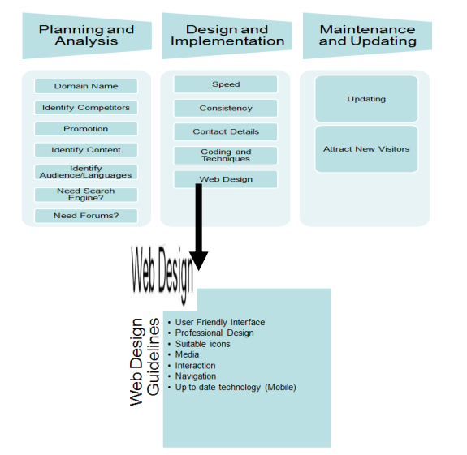

Figure - Frameworks Implementation

(Mohammad, Ghwanmeh and Al-Ibrahim, 2013)

A framework is a high-level solution for reusing software packages, a step forward in easy library-based reuse that support solutions similar attributes and a domain application's standard logic. This also provides a higher quality standard for the finished product, because one essential aspect of the specification has already been identified inside the system and has thus already been reviewed (Salas-Zárate et al., 2015). Angular is a popular Google-supported JavaScript Platform. It provides a large collection with plenty of user-written extra plugins. This framework is becoming the backbone of several projects because of the reuse of code it provides full front-end development, powerful performance and less development time.

* The use of MVC architectural pattern.
* User Interface can be developed with HTML.
* Ready-made templates to build the framework faster.
* The use of the "plain old JavaScript objects" model.
* The built-in dependency injection subsystem.

This framework is used by such companies as Google, Microsoft, PayPal, and other tech giants (Shirazi, Haefner and Ray, 2017). Frameworks are a particular type of software or scripting libraries, which vary widely from them in that they are reusing abstractions of code wrapped in a well-defined application programming interfaces (API). These also possess some primary distinguishing characteristics that differentiate them from standard libraries (Bifet et al., 2011).

Some advantages of the framework are (Manger, 2010): Open-source, Documentation and support, Efficiency, Security and Integration. Many common frameworks are open-source (or are available for free use) in several languages. They also come with non-restrictive licencing and able to build specific products using those frameworks (Hasan, Morris and Probets, 2013). Also, some of the dis-advantages of the framework has be identified like: Limitations, Performance, Learning bias, Steep learning curve and Cost. Implementation could also be identified as a factor with the relevancy of client-side JavaScript MVC frameworks such as AngularJS, EmberJS and BackboneJS increasing since 2012. The frameworks involve more expertise and experience in implementation than most integrations. Hiring reliable System Developers can also be more costly than inexperienced WordPress Developers (Hasan, Morris and Probets, 2013).

### 2.2.2 How can a website be implemented by using the ASP.NET MVC (Model View Controller) technology?

Model-View-Controller (MVC) programming (Krasner, Pope and Systems, n.d.) is the implementation of this three-way computation, in which artefacts of various classes take over discovering important to the application domain (model), representation of the application state (view), and user interaction with the model and view (controller). ASP.NET MVC is Microsoft's open-source Platform. The software development system puts together the functionality of MVC (Model-View - Controller) design, the most up-to - date Agile development concepts and strategies and the best sections of the current ASP.NET platform (Sarker and Apu, 2014).

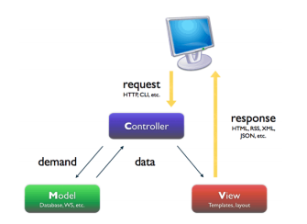

Figure - MVC Technology

(Pop and Altar, 2014)

Trygve Reenskaug first conceived the MVC architecture model at Xerox Parc in the 1970s. As per him, "MVC 's fundamental aim is to close the gap between cognitive properties of the human user and the digital model present in the machine". The MVC pattern divides responsibilities into three major duties, thus enabling more effective collaboration. Growth, design and integration are those key roles (Pop and Altar, 2014). Software developers who are accountable for the application's logic assume the development role. They do data query, validate, process and more. The design role is for the development team who are responsible for the appearance and feel of the site. They view data provided from the programmers who are operating on the first function. The position of integration combines programmers with accountability for gluing the work of the two previous positions.

The MVC (Model-View-Controller) technology (Prabowo, 2015) is broken down into three different parts, the three different parts are:

* Users
* MVC components
* Database

The very first stage is only composed of users. User can submit requests and get reaction from the middle stage's 'View' components. Secondly, there are three elements called 'Model, View and Controller' in the middle stage. These components can interact with each other, and process information. Finally, the third stage contains only the database where permentally the data is stored (Berardi, Katawazi and Bellinaso, 2009).

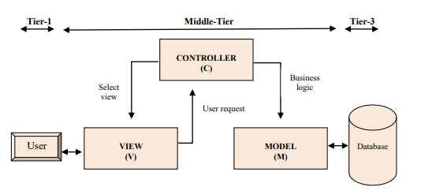

Figure - MVC Framework

(Sarker and Apu, 2014)

User feedback is acknowledged via the graphical user interface (GUI) through the 'View' element. The user interactions can be button clicks or menu selection in a stand-alone GUI client. The 'Controller' mechanisms requests from users. The Controller calls methods in the View and Model to perform the desired action on the basis of the user request. The 'View' takes responsibility for the model 's performance. A simple GUI view connects to a device and allows the display surface to its contents (Berardi, Katawazi and Bellinaso, 2009).

|  |  |
| --- | --- |
| Strengths | Weakness |
| Gives precise control across created HTML | Not event driven by the framework, so it may be more difficult for ASP.NET webform developers to understand |
| Clear separation of concerns | Requires the need to understand, at least at basic level, HTTP, HTML, CSS and JavaScript |
| * Supports all the core ASP.NET features, like authentication, caching, membership and so on | * Third-party library support is not as strong |
| * Size of pages generated typically much smaller because of the lack of view state | * No direct upgrades path from Web Forms |
| * Easy integration with JavaScript frameworks like jQuery or Yahoo UI frameworks | * No ViewState and PostBack model |

(Pop and Altar, 2014):

Table - Strength & Weakness of MVC

### 2.2.3 How communication and good understanding between you and client can make you build a good website?

Web application creation (Bolchini and Paolini, 2003) also needs to use appropriate methods to Facilitate some different features of the requirement analysis process: collecting high-level communication priorities, considering multiple web pages and participants, identifying hypermedia-specific criteria (concerning navigation, content, information structure and presentation aspects) and reusing requirements for an efficient usability evaluation. In addition to client satisfaction, the client must be engaged to each Website production phase and his / her goals and prior experiences should be taken into account. The website must be not only right in itself but, above all, it should fulfil the aims for which it has been created (Alghamdi, 2012). Every communication apparition (and a web application can be called a communication way) is adequately built if and only if it has the quality of congruency, i.e. if it is consistent with the purposes it will meet. For a web application, every overall objective can be to improve the user experience and, at the same time, to meet the needs of the customers that developed the application. Identifying the priorities and the criteria is the Activities have been carried in every development process and the actual quality of a design is primarily related to how well it suits the specifications (Bolchini and Paolini, 2003).

To develop an immersive website (Degelman, 2015) that addresses all user requirements the project goals need to be explained first. Usability criteria are a collection of characteristics that can assess and analyse a given website, and identify and fix the weak points. The essential towards effective website is good contact between web developer and client. Communication problems between both the developer and the customer arise when the developer is not very skilled in assessing the company website ideas / suggestions and if the customer is not sure what he wants for his website the same way the experienced user will face the problems (Mazzoleni, Rembert and Subbian, 2015).

User specifications apply to features / attributes (Bland and Nepustil, 1998) that your programme or framework should have or should execute prospectively from the user. User-centred design is a discipline where needs are gathered and evaluated. User-centred design is a process to system development which focuses on system end-users. The concept is that the programme should match the user, instead of having the user match in with the programme. This is achieved by the use of strategies , procedures, and approaches that concentrate on the consumer during the product lifecycle. (Courage and Baxter, 2005). User-centred web development applies to "a process of designing a website which meets user needs. It emphasizes the importance of user participation in the development process to achieve the highest degree of customer satisfaction. Web design focused on consumers is a very useful approach in ensuring the usability of a website. Facility of use and navigability seem the top UCD (User-centred design) benefit (Alghamdi, 2012).

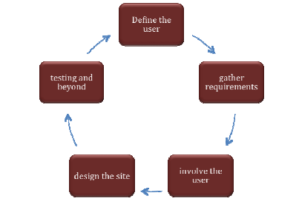

Figure - Good Communication

(Alghamdi, 2012)

The value of collecting requirements is frequently misunderstood on several scales. If budgets are low, schedules are short, and scope creeps, documentation on specifications appears to be the first component to go and the last deliverable to be considered. We typically see two types of specifications in web design and in services. There's also other forms, such as financial and institutional specifications, and the person in charge of managing specifications documents may need further experience in professional writing, visualization of details and more, depending on the context (Geissler, 2001). There are two types of main requirements for the web development: Functional and Non-functional requirement. Functional requirement refers to the functionality of a system: its capabilities, accessibility, functions and processes as they refer to the product's intended purpose. Non-functional requirements cover everything that is not linked to the functionality of a system: its efficiency, reliability, safety and technical specifications, to name only a few examples of non-functional requirements in the digital industry. Documentation of both functional and non-functional specifications is similarly important in its own ways. They live hand in hand; one is influenced directly by the other (Bolchini and Paolini, 2003).

### 2.2.4 How a web-designs is important for the website?

The Web design (Powell, 2002)strategy involved a variety of things for different people. Web design based on the user involves several aspects like graphic design, programming, HTML, problems with navigation, usability and business (e-commerce) issues. In reality, focusing on the project web design can rely from all of these areas so it can really be a very multidiscipline environment. There are four critical elements of web design: content- informing or persuading people, technology- implementing the website feature, graphics- providing website forms and economics- providing intention for the website. The impact of one or the other aspect of site design varies according to the project.

For example, by using the internet, an organisation can easily access consumers and provide them not only with general knowledge about their goods or services but also with the ability to make direct business transactions (Cebi, 2013). Efficient website design also plays a significant role for organisations who want their revenues to be maximised by supporting their services or products in a successful and restricted market. There are various design specifications that must be taken into account concurrently in order to design an effective website. Design specifications can be defined as qualitative and quantitative aspects of a website's physical and functional characteristics which play an important role in efficiency of website design. Due to its dynamic existence based on human perceptions, however, it is not easy to decide the design parameters of a successful web design (Gevorgyan and Porter, 2008). Thus, web designer must take into account a growing number of design parameters such as usability, accessibility, cost, delay, efficiency, protection, maintenance, etc. during the design process to meet the needs of users. Hence, consideration has been given to the design parameters of a successful website to improve the efficiency of the websites (Gevorgyan and Porter, 2008).

Web design is like a pyramid, the content we use as bricks to create the pyramid, the structure of the project is based on graphics and technology and economics makes the project worth doing (Powell, 2002).



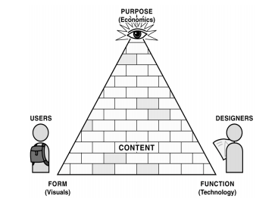

Figure - Web Designs

(Powell, 2002)

Web design (Flavian, Gurrea and Orús, 2009)has been described as a key factor for website acceptance and performance. In order to create an effective website, we examine from a marketing point of view the key factors that may affect the attitudes and behaviours of online users. Website design has been intensively researched from multiple perspectives, most of them identifying the factors that could reflect the extent of website acceptance, designing is "the method of constructing an object with a scheduled, creative, consistent, meaningful and helpful form structure." Through a customer viewpoint, a website with all these features must be designed to arouse the users' affective states and to improve their online visits or purchase intentions (United States and United States, 2006).

Anyone who wants more control over a page's layout may choose to design a Web page with a fixed width which remains the same for all users, regardless of their monitor size, or the resizing of the window. That web design technique is Based on design concepts learned in print, such as the maintenance of a constant grid, page element relationships and convenient line lengths. Below mentioned will be some advantages and some dis-advantages of the web design technology (Dringus, 1997).

|  |  |
| --- | --- |
| Advantages | Dis-advantages |
| Regardless of the display size the web page would appear the same. That is also the case Crucial for businesses wishing to show a positive corporate picture every member. | If the available browser window is smaller than the grid for the page, parts of the page will not be visible and may require horizontal scrolling to be viewed. |
| Pages and columns with set widths have greater control over line lengths. Tables can be used to avoid lengths of the line from becoming too long when the page is shown on a large monitor. | Management of type size in browsers is still difficult, and objects may still change irregularly due to a larger or smaller type than was used during the design process. |

Table - Advantages & Dis-advantages of Web Designs

(Dringus, 1997)

### 2.2.5 How data warehouse or a database can be designed for the project in MS SQL?

A database (Yarger et al., 1999)is an ordered collection of data which defines some function as per the concept of a database. Only getting a DBMS isn't enough to give meaning to your database. The aim determines how you use your data. Database design is part of the learning process of database creation which focuses on the analysis of a proposed solution (specifications and requirements) and includes all the required findings for the construction of a logical data model (Letkowski, 2005). Such as DDL (Data Definition Language) (consists of SQL statements within relational database systems, which generate databases along with their tables, views, indexes, etc. Usually, data models are represented as Entity Relationship Diagrams (ERDs) and perhaps most modern database design tools are capable of translating the diagrams into metadata. Commercial database management systems (Agrawal et al., 2004) support many variations to physical design such as tables, materialised views, and various types of hierarchical data partitioning or indexing structures.

Database (Weikum et al., n.d.) takes as its input a workload comprising of T-SQL (SQL Server language flavour) statements such as SELECT, INSERT, UPDATE, DELETE, stored procedure calls, dynamic SQL and DDL statements and generates a T-SQL script comprising of index suggestions, materialised views as the output (Called Microsoft SQL Server indexed views), and horizontal partitioning. A database can have several tables and columns, clustered or non-clustered indexes, single-column or multi-columns. Relevant data such as originality, source limitations and basic statistics ("small" vs. "big" tables) to produce a database design performs poorly because it ignores valuable information about the workload. Current query optimization techniques use dynamic techniques such as intersection of indexes and access only by number. Thus, making an optimizer's accurate model and keeping it stable as the optimizer progresses is an incredibly difficult job and will possibly result in the collection of indexes that the optimizer does not use when creating a plan as required by the index selection tool (Weikum et al., n.d.).

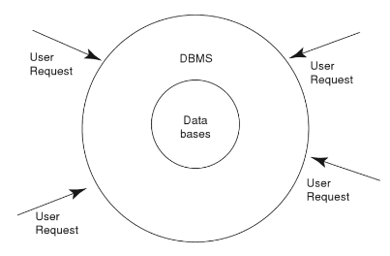

Figure - Datawarehouse Design

(Norman, 2006)

Databases include administrators (Chaudhuri and Narasayya, 1997) accountable for performance optimization of databases. With large-scale database deployment, to reduce the role of administration of databases becomes essential. MSQL aren't databases, actually they are computer software which makes user creating, maintaining and managing the electronic databases. This Application group is known as the Database Management System (DBMS). A DBMS acts as the dealer between that database's physical database and its users (Yarger et al., 1999). As SQL is an approved framework for relational databases, and enables for declarative, set level, substantially optimised expressions, it is desirable for users to be able to use SQL primitives such as sorting, group-by, and others such as these within MSQL, and to express nested queries using SQL nested query constructs such as [NOT] IN, [NOT] EXISTS etc (Imieliński and Virmani, 1999).

MsSQL is what has been known as DBMS (Database Management System). The management solution defines how the data is processed, stored and retrieved and how user access to it is managed. Every time the user retrieves data, deletes data or adds more data the request is handled by the DBMS. The user can not directly access the data files and can only talk to the DBMS (Norman, 2006). The input to the method is a set of databases and a workload (a set of queries and procedural calls inserts / updates / deletes / stored). One way to get such a reflective task is to use tools such as the Microsoft SQL Server Profiler that logs server events. Conversely, metrics unique to consumers or to organisations can be used (Agrawal et al., 2004).

### 2.2.6 What are the methods and system to improve security of website?

While WWW becomes more and more complicated, there are several problems that have to do with the protection of the website (Taral and Gite, 2014). Security of websites is the most critical aspect of the web construction post design phase. Web publisher has to review the websites and website audit so as to prevent unwanted surprises. Important to remember that security is never a set-it-and-forge-it solution. Rather, it's a continuous process that requires constant evaluation to lower the total risk. We may think of it as an onion by applying a systemic approach to website security, with several layers of protection joining together to form one object (Hanes, 2013).

Often the easiest methods of resolving any problem are the safest. Below are some of the simple ways to improve your website security (Sheleheda et al., 2015):

* **Update Everything**

It’s important having all applications and scripts that you've built up to date is important. As soon as a new plugin or CMS version is available it is essential to upgrade your account. These upgrades can contain only improvements to security or fix a weakness. Hackers are actively targeting security vulnerabilities in common web applications, and need to upgrade the programmes to plug security holes. It is essential that every software product you use is maintained and updated. Most threats on the Website are streamlined. Bots constantly scan every site they can for any possibilities of impoverishment. Updating once a month or even once a week is no longer good sufficiently, because spammers are very likely to find a weakness before patching it. That's why you should use a website firewall which will fix the security vulnerability virtually as soon as updates are published (Sheleheda et al., 2015).

* **Have Strong Passwords**

Having a secure website depends a great deal on your safety viewpoint. Using the strong passwords is necessary. Hackers regularly use specialized technology to crack passwords, using extreme strength. To clear up contaminated websites, remediators need to log into a client's website or server using user information of their admin. Passwords must be complicated, with upper case letters, lower case letters, numerals and special characters to defend against brute strength. Your passwords have to be a minimum of ten characters long. This password policy should be kept across your organisation (Sucuri, 2019).

* **Install SSL Certificates**

SSL certificates are often used to transfer information between the server (web server or firewall) and the client (web browser) during transportation. This will make sure the information has been sent to the appropriate client and not intercepted. Many forms of SSL certificates like company SSL or extended SSL authentication provide an extra layer of authenticity so the client will see the specifics of your company and recognise that you are a transacting (Taral and Gite, 2014).

* **Have Websites Backups**

In the case of a breach, server backups are vital if the server is to rebound from a significant security accident. Although it should not be considered a substitute for getting a secure system for the website, a backup that help to recover damaged data. Backup the website frequently. Backups of all your website files must be preserved in case your site is unavailable or your information is lost. Your hosting service provider will have copies from their own servers however, your files must also be backed up periodically. Most content management systems have plugins or extensions which will back up the site remotely, so you will also be enabled to manually back up databases and information (Sheleheda et al., 2015).

* **Limit User Access & Permissions**

Website functionality will not be attacked by an intruder but there will be users. Later IP address documentation and all records of operation would be useful in network forensics. For example, a large rise in the number of active members can signal a weakness in the verification process and allow hackers to overload your site with viral accounts. Client functions and access rules are clearly defined to minimise any errors that might be made. This also reduces the effects of hacked accounts and will guard against the harm that rogue users inflict. Holding audit logs is essential to keeping the website on top of any suspect changes. An inspection log is a report that documents the activities on a website so you can find irregularities and check that the database has not been breached with the person in charge (Sucuri, 2019).

### 2.2.7 How can you link website quality with customer loyalty?

According to (Antanas, 2019)Your website is the organisation's face and several customers look to receive everything on the company website that they want and need. Loyalty is among the most important topics these days. Each shop would want to have a broad loyal community of customers (Antanas, 2019). In the online environment, consumer loyalty is difficult to overcome than in the offline one. When a website has high quality of content, system and service, consumers will be more likely to sustain, deepen and extend their relation to a specific provider of online services. Moreover, in order to achieve the aim of online consumer engagement, businesses need to consider the unique electronic marketplace environment.

According to (Liang and Chen, 2009) Good content may be text, video, any kind of digital sound, or other stuff. All content is added purposefully to satisfy consumer needs with lack of attention. It has been shown that excellent service attributes create customer loyalty which is expressed in retaining customers, word-of - mouth endorsement, premium payment and bridge-buying. Some of the factors include like Personalisation, interactive content, information, background and network quality, sophistication, technological integration, accessibility, information quality, software quality, unique content and adjustable, website design, order delivery, communication, protection / privacy and information quality, speed of transaction, user-friendliness and security are all considerations.

Consumers typically expect three website attributes to help their online purchase, which is information quality, quality of the system and quality of service (Kassim and Abdullah, 2008). **Information quality** is the performance value of an information system (IS), which has been calculated in terms of precision, simplicity of interpretation, efficiency, comprehensiveness, importance and whether it has been up to date. In addition, a website with a high level of data can help the organization deliver personalised, creative, and value-added components / services to its clients. The more the information presented on a website is beneficial and comprehensive, the greater the likelihood that the website will obtain and retain customers. **System quality** is the production quality of an IS that has been assessed with respect to ease of use, usability, accessibility, flexibility, reliability and responsiveness. The quality of the system is thus influenced by factors such as fast page loading, consistent layout and easy, side access. Furthermore, fast, efficient and reliable transfer processes are also very critical for transaction completion. **Quality of service** is the total assistance offered by the online service provider, which was calculated in terms of reliability, empathy and tangibility. Quality of service as an important factor for success of the information system. Online companies must also pay attention to the pre- and post-purchase customer interface operations intended to enable both instant transactions and long-term customer interactions, such as making sure no collapse in system, and immediately resolving any customer-related problems (Kuan, Bock and Vathanophas, 2008).

# **Chapter Three: Research Methodology**

## 3.1 Qualitative Research & Quantitative Research Methods

The aim of this investigation is to explore the answers to investigative questions. There are two qualitative, and quantitative types of methodology. According to (Kothari, 1990) Popular usage work refers to a knowledge search. Once again study can be characterised as a detailed and systematic search for relevant knowledge on a particular subject. Research is a scholarly practise and the concept must be used in a scientific context as such. Work involves identifying and reinventing concerns, developing theories or possible solutions, gathering, organising and analysing data, making assumptions and drawing conclusions, and eventually carefully checking the assumptions to decide if they match in with the study to formulate hypothesis.

The methodology to be decided relies on the study problem complexity (Mackey and Gass, 2015). The quantitative analysis is based on size or quantity measurements. Whereas Qualitative research is concerned with the amount of work done. The methodology below will be addressed using the methods of qualitative & quantitative analysis that include Surveys and Questionnaires, Telephone Interviews, User Interviews and Face To Face Interviews (Kothari, 1990). Quantitative work is focused upon quantity calculation or quantity. This refers to occurrences which can be represented quantitatively. And the, qualitative research concerns a qualitative process, i.e. phenomena linked to, or including, consistency or type. Of example, when we are engaged in studying the motives of human actions (i.e. why people think or do such things), we often speak about 'Motivation Analysis,' an essential form of qualitative study (Groves et al., 2011). This method of study is aimed at exploring the underlying motivations and interests, utilising the objective of in-depth interviews. Some such testing strategies include word recognition tests, discourse completion tests, storey completion tests, and many other projective techniques. Applying qualitative research to the application of Research Methodology is a fairly complicated process and thus one should receive advice from experimental psychologists when doing such work (McKeown and Thomas, 2013).

## 3.2 Data Generation Methods

### 3.2.1 Interview’s

The interview is among the techniques being used commonly to obtain qualitative data. In this work interview approach is chosen to better explain how and what people think of getting a website. Through setting up the user interview process, in contrast with the Questionnaire approach, the subject can be elaborated more deeply on. Interview questions are usually querying that are clean-ended to obtain in-depth awareness of subjects than other methodologies. When correct information is gathered, this benefits the investigator too. Additionally, the researcher may ask some questions as per the responses of the respondents to clarify their viewpoints in detail. Interviews provide the opportunity for the public to share their perspectives.

While the interview process is intended to be a little lengthy, it is the best way to obtain quite enough accurate knowledge about the research subject as possible. Telephone, internet, and face-to - face interviews are also the methods which may take place. For example, an investigator can make an arrangement to setup an interview, also a voice call can be made for interview and the best case can be by making video calls for the interview process.

**Telephone Interview:** Confrontation with stakeholders is not always feasible and this is where telephone interviews can be particularly useful. These also help us to quickly and efficiently create the qualitative data. User habits, desires and thoughts can really be digged over the telephone, so it's always useful to find out what actually bothers people when they interact with an agency or website, telling us something to avoid.

**Face-To-Face Interview:** This can provide the additional advantage of seeing the emotions of the interviewees as they clarify, providing more insight on emotional reactions and motives. Interviews face-to - face can be performed in user's residences, workshop environments, focus groups and even on the avenue. Often, we can combine interviews with user research, as it encourages users to ask for tasks to be completed, see how they proceed and then question them about their impressions afterwards, which contributes to a deeper assessment process.

### 3.2.2 Surveys & Questionnaires

Survey and Questionnaires are the best and easiest quantitative method to answer questions relevant to the study subject. A Survey and Questionnaires system for answering research questions is utilized in this report. Developing quantitative data is critical for us to be able to determine trends in users' preferences, hopes and desires. Surveys and Questionnaires gather a clear insight easily from several various user groups; via established consumer email info, targeted advertisement ads (such as on Facebook) or even pop-up web site surveys. Surveys and Questionnaires are the best strategy, as it can be done numerically or by picking the text option to answer the question of the study. Information obtained through Surveys and Questionnaires is straightforward to analyse. Since nearly people can undertake surveys, data can be retrieved from an enormous number of people.

All methods of approaching a customer base are true, it varies just on which user categories you seek to offer knowledge into and how best to reach them. Survey and Questionnaires should spend a little less time and less time than the method of interviews. People are able to complete tasks very quickly but can provide the most efficient information on the survey questions. Surveys and Questionnaires are also very straightforward for the people to complete, as it can only be by clicking the radio buttons or ranking comments between 1 and 5.

### 3.2.3 Focus Groups

The focus group is an approach that relies solely on the conversation that the participants create. Members are required not just to reply to the moderators but also to other attendees' comments, and to participate in more contemplation of life observations as others talk. In this project Focus Group Methodology has been used to discuss the requirements of the project and for the design of the website. At the time of the requirements discussion of this project myself being a moderator and involving the chef, owner and admin of the business to do a brain storming and gathering the ideas to build the website.

Focus groups has a very well-documented tradition, however challenged, as a means of gathering data in both public and private sector organisations. These have indeed become a proven and integrated part of the range of analytical methods available to academic researchers in more recent years. Throughout research, focus-group interviews have become extremely prevalent to investigate what people believed or think as well as why they act in the way they do. A focus group is a methodology including the utilization of in-depth group interviews in which individuals are chosen as being a purposeful, but not typically representative, sample of a particular population, this group being 'based' on a specific subject. Focus groups may provide data on a range of participants' thoughts and feelings about other topics, as well as highlight the gaps in viewpoint amongst groups of people.

Qualitative research, and interviewing with focus groups in particular, produce vast volumes of data, that appear to exhaust novices as well as accomplished researchers. The focus group has been very well preplanned in the research literature Conversations represent a type of group conversation in which people are invited to debate particular subjects in a fairly casual environment so that fundamental problems (norms, views, values) relevant to the experiences of all respondents can be revealed.

# **Chapter Four: Design Consideration**

The design considerations are developed in order to draw the developers' exposure to understanding the ideas and specifications of user requirements layout to structures and installations. There were many prototypes that had to be examined before another development process began. The models that were mentioned are Gantt Chart for Project Management, Application ERD chart, Class Diagram, MVC conceptual design, and GUI Development frontend.

### 4.1 User Interface Design (UI Design)

UI design is a critical feature of virtually all computer systems. UI projects have been responsible on several injuries and disasters (Stone et al., 2005). Creation of a web interface is simpler if the author has a good understanding of the website's architecture and format (Galitz, 2007). Initially, for the UI design of the restaurant website project, all web pages were produced and the descriptions were defined for all web pages. This made it a lot easier how many pages the system needs, and how all of the functionality would be arranged on web pages. Furthermore, the Website template has been set. For example, the navigation style, the location of the logo, and the system architecture of functions on web pages. Using the template trend during the development process was easier. (Appendix 1)

4.2 ERD (Entity Relationship Diagram)

The ERD was seen as a very effective way to incorporate a logical database model. ERD is a visual way of presenting data base knowledge inside the system. Using database developers with an ERD diagram will translate this knowledge to generate a database table (Al-Masree, 2015). It is a structural diagram used in database design which helps the developer visualize the major entities of the system, dataflow and relationships amongst entities. It helped me to identify the tables, fields, and relationship between each table. There are eight tables in this project website Database; they are Customer, Order, Food Items, Payment, Order Details, Order Status, Card Payment and Cash Payment. (Appendix 2)

### 4.3 Class Diagram

Class diagram defines the device class structure, its properties, methods, and relationships. This is being used for oriented modelling of the proposed application, and for comprehensive modelling that translates the concepts into programming code. Data modelling can also be performed using class diagrams. In this project there are major classes like Customer, Payment, Order and Order Details. (Appendix 3)

### 4.4 Gantt chart

The Gantt Map is used in the preparation of activities. Following the Gantt chart, completion of tasks in the scheduled timeline becomes simpler. It supported coordinate various project activities in a reasonable period of time and predicted the achievable goal date that required to be within the time limit (Maylor, 2001). Nevertheless, certain additional time for this kind of circumstances was provided in my Gantt chart towards the end of a project preparing. It was substantially difficult to estimate the timeframe for execution of the projects, because for the first moment much of it had been acknowledged. Because for the first moment almost all of the activities were viewed, the design phase was going lengthier than initially planned.

### 4.5 MVC Design Pattern

The MVC proposed architecture had been perceived for implementation in this project. Implementation was divided into three different modules: model, view, and controller. The system architecture (Rayfield, 2001) Model View Controller is very beneficial in the architecture of informational software systems. This method of development is partition-independent, since it is represented as an integrated application running in a single program place address.

### 4.6 Web Forms

Use of ASP.Net web forms was regarded as an alternative. It allows the developers to evolve a software by simply dragging and dropping elements, and treating the software as an unit instead of different client and server instructions (Jarrett and Gaffney, 2009). It is a simple way of designing and constructing the software. This is also not very productive so there isn't much flexibility for software design and functionality with JavaScript and CSS.

### 4.7 New concept Learned

The N-Tier(3-tier) MVC Framework has been used following some additional work. (Hamdania, 2019) With modelling techniques, controllers, and views it is similar to MVC Architecture. Even so, there are two separate projects added in this project called DAL (Data Access Layer) and BLL (Business Logic Layer).

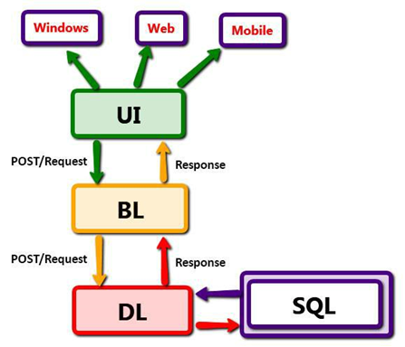

Figure - N-tire MVC

This layout helps programmers to view and model availability to the database, so that multiple programmers could even function on independent sites without impacting anyone else. If system extension is assumed in the possibility, then N-tier Architecture would allow me to recreate my coding on a different server and different DAL project and BLL project.

**DAL (Data Access Layer)** is implemented to establish an connection with the database server, the framework creates statically typed objects in a popular data access portion that encompass raw, untyped data access logics and works together like database commands (Minore, Yuknewicz and Lasker, n.d.). In DAL we call stored procedures from the database for an insert, delete, edit, and other operational processes. The BLL (Business Logic Layer) only communicates with this DLL (Data Access Layer).

**BLL (Business Logic Layer)** The programme includes a growing component of business logic that is Its business logic encapsulates objects in a store (Barber et al., n.d.). Classes in the logic layer determine what information they need to fix their allocated issues, demand that data collected from the accessor layer, exploit that details as needed and return the final results for configuring to the user interface (McGovern, 2003). BLL acts as an alternative layer communicating with DAL and UI (User Interface). It has been used when calling the DAL, to verify the source conditions and modify the data. In BLL all database access codes are generated and validated according to proposed project. In my BLL layer project scenario the processing of data is checked before it has been stored in my database.

**UI (User Interface) or presentation Layer** is a layer of user experience, in which we can build our web pages. This is where you can introduce all the Html documents and the template controller. It is an abstraction phase among both participants and BLL (Business Logic Layer) in which clients are able to provide input and get the desirable result. This project involves controllers that retrieve the information from the database smoothly and make it readable. Below we will see the breakdown of this project in N-Tire Architecture:

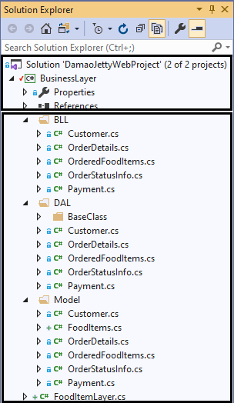

2nd Layer – BLL & DLL and Model was implemented.

1st Layer - In this layer Views and Controller were implemented.

3rd – This is the database which stores the data for whole application.

DATABASE

Figure - Presentation Layer

ORM (Object Relational Mapping) system is easy to perform in contrast to N-tier Architecture and links to design. It is similarly useful for projects of minor or moderate scale, as it generates a wide range of complex scripts. The architecture is finding it tougher for new developers to follow. In addition, .Net Framework supports MS-SQL and Entity Framework that also enables for complicated structures with short analysis script. And using this framework, fortunately, results in difficulty for software entrants is not advantageous if you want to reprocess the code for different projects, though if the project isn't extraordinarily huge, it makes life easier for designers (Rok, 2000). Visual Basic facilitates the database schema of an ado.net object, this software automatically extracts classes from databases, and constructs the dataset dependent on classes that would have been useful in my project. N-Tier architecture is mounted, therefore, and if the project needs to be extended in the context, separating DAL, BLL, views and Database on a different drive is simpler for better performance.

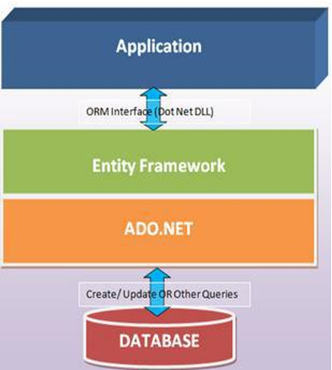

Figure – Framework

Below we will be discussing some advantages and dis-advantages for the MVC architecture:

|  |  |
| --- | --- |
| Advantages | Dis-advantages |
| 1. It finds ways and improve the efficiency of large-scale projects because of distributed layers. | 1. This adds an extra layer of enable reliable as the communication layer is growing. |
| 1. User application data manipulation is reduced because all information is checked by the middle layer, BLL, before being loaded into the server. | 1. This also shows the volume of implementing rules which impacts the efficiency of technologies such as Visual Basic. |
| 1. It improves security, as all there is much less chance of violence with unapproved data. Also, it allows developers to integrate additional features into the project despite impacting all levels |  |
| 1. As its implementation is separated into different levels, reuse of any layer for several other projects is easy. |  |

Table - Pro’s & Cons of MVC Framework

# **Chapter Five: Requirement Analysis**

## 5.1 System Requirements

* The system will allow the customers to access to the food menu item, it will also allow the customer to buy the top listed items from home page without going into menu page.
* The system will allow the customers to place order of item through the website, also to amend the order from website which will give alert to the restaurant for customers’ orders.
* Once the customer has placed the order the system will generate bill summary for customers. The system will then accept the payment online from customer.
* When customer pays the bill online, the system will send a receipt to the customers email address.
* The system will show the customer a tracking of their orders, once the order is finished by the restaurant the system will send an alert/message to the customer.

## 5.2 Hardware Requirements, Constraints & Needs

* Laptop or desktop will be required with windows 7 or 10 / Macintosh OS which has minimum of 4GB RAM.
* For front-end coding of the website the latest version of the visual studio will be needed like Visual Studio 2017/2019.
* Latest version MS SQL to create a database of the website, which will store all the data of the website contents.
* The budget of website can be maintained by avoiding scope creep, this can be avoided by better communication and understanding with the client.
* System will help the restaurant owner to handle and manage their orders to keep the flow of restaurant smoothly.
* Website front page will be created in an attractive way to avoid the bad impression of customers and also with easy navigation structure of website.
* Keeping the text/fonts very clearly visible, so the customers can face easy navigation of website.
* Best runs on Google Chrome (developed and tested using Google Chrome).

## 5.3 Use Cases

A use case is specified by a particular goal of the user, what the user needs to accomplish, the below points are the use cases of this application listed: (Appendix 4)

* **Actors**: Chef, Owner, and Customers

**Use Case 1:** Placing Orders

Primary Actor: Customer

Goal: To place order of food items

Preconditions: Food item is available to place order

Success Condition: A specific food item is placed by the specific customer

Main Sequence:

1. The customer will click on the menu page of the website to view food items.

2. The screen will display the food item to the customer

3. The customer will select the food items

4. The system will show the item description and option to add food item to cart

5. The customer will add the food items to the cart

6. The system will show the food items added to the cart by customer

7. Customer can increase the quantity of the item in the cart

8. System will display the quantity for the item

9. Customer will click on the button confirm & pay

10. System will display the screen to fill out card details

11. Customer will fill all the details and click on pay button

12. System will display a message to customer saying ‘the order is confirmed’

**Use Case 2:**  Preparing Orders

Primary Actor: Chef

Goal: To Prepare Orders

Other Stakeholders: Customer

Preconditions: Sufficient ingredients item is available to prepare order

Success Condition: An order is prepared and completed on customers request

Main Sequence:

1. Customer places and food item order online

2. System will show the food orders on the Chef’s portal screen

3. Chef will click on the button to view the orders

4. System will display the orders on the chef screen

5. Chef will then prepare the food orders as requested by customers

**Use Case 3:**  Passing alert to customers regarding their order completion

Primary Actor: Chef

Goal: To send alert to the customers, when their orders are completed

Other Stakeholders: Chef, Customer

Preconditions: Customer’s mobile number can be mis-typed

Success Condition: An alert is sent to customer’s when their order is finished

Main Sequence:

1. Chef completes preparing the order of customers as requested and marks as complete.

2. System will display the order status as completed with the order number.

3. Chef will click on the button and pass the message to the customer.

4. System will send an alert to the customer indicating related to their order status.

5. Customer will receive a message/email stating the order is now ready to collect or delivered.

**Use Case 4:** Providing online receipt

Primary Actor: Owner

Goal: To send receipt to customer of their order

Other Stakeholders: Customer

Preconditions: Customer’s email address can be mis-typed

Success Condition: Send receipt to customer’s email after payment is completed

Main Sequence:

1. Customer completes the payment process

2. System will display the payment confirmation to the customer

3. System will add new order in the admin portal for the food to be processed by chef.

4. System will send a receipt to the customer.

5. Customer will receive a receipt in their provided email.

**Use Case 5:** Providing feedback

Primary Actor: Customer

Goal: To give feedback to the restaurant on their orders/services

Other Stakeholders: Owner

Preconditions: Customer must use appropriate action to provide feedback

Success Condition: Send feedback message to the restaurant

Main Sequence:

1. Customer will click on the ‘Contact Us’ page on website/Application

2. System will display the Contact Us page with details and feedback form

3. Customer will fill out the feedback form by providing the details and a message

4. Customer will click on the send button to post/send the feedback to the restaurant

5. System will display a message to customer stating ‘message sent successfully’

**Use Case 6:** Making Payment

Primary Actor: Customer

Goal: To make payment online through the website

Preconditions: Customer must use valid bank card

Success Condition: Making payment online for the order

Main Sequence:

1. Customer will click button confirm & pay

2. System will display the payment option with payment options

3. Customer will select the option which suits to make payment

4. System will display the dialogue box to fill in the bank details

5. Customer fills out all the details and click on pay button

6. System will verify the payment details with the bank

7. Customer will receive a confirmation ‘payment successful’

**Use Case 7:** Adding food item to the menu

Primary Actor: Owner

Goal: To update the menu by adding new food items

Other Stakeholders: Owner

Preconditions: Menu item must be tested before adding

Success Condition: Adding new food item to the menu

Main Sequence:

1. Owner will login to their portal

2. System will display the login detail dialogue box to fill details

3. Owner will fill the details and press login

4. System will display the website pages with editing options

5. Owner will click on menu page

6. System will display the menu page

7. Owner will insert the image, description and price of the new food item

8. Owner will click save

9. System will display the message ‘webpage edited successfully’

**Use Case 8:** Editing the contents in the website

Primary Actor: Owner

Goal: To ensure all the content of the website is correct

Preconditions: All the contents must been check before launch of the website

Success Condition: Correcting the content of the website

Main Sequence:

1. Owner will login to their portal

2. System will display the login detail dialogue box to fill details

3. Owner will fill the details and press login

4. System will display the contents of the website pages with editing options

5. Owner will edit the contents in and save website

6. System will display the message ‘webpage edited successfully’

**Use Case 9:** Request for events ordering

Primary Actor: Customer

Goal: To make inquiry regarding the big events orders

Other Stakeholders: Owner

Preconditions: Correct action must be taken for inquiring the event orders

Success Condition: Send message to inquire regarding the event orders

Main Sequence:

1. Customer will click on the Menu page on website/Application

2. System will display the menu items and inquiry form at bottom for events order

3. Customer will fill out the inquiry form by providing the details and a message

4. Customer will click on the send button to send the inquiry to the restaurant

5. System will display a message to customer stating ‘message sent successfully’

**Use Case 10:** Response to customer’s inquiry

Primary Actor: Owner

Goal: To response back at customer’s inquiry

Other Stakeholders: Customer

Preconditions: Correct action must be taken to reply back customer’s inquiry

Success Condition: Send message to customers regarding their inquiry

Main Sequence:

1. Owner will login to their portal

2. System will display the login detail dialogue box to fill details

3. Owner will fill the details and press login

4. System will display the website pages with editing options

5. Owner will click on the message icon where they will receive any kind of messages or inquiry requested from the customer

6. System will show the messages to the Owner

7. Owner will click on the unread messages

8. System will display the message to read

9. Owner will click on the button ‘reply’

10. System will open a dialogue box where admin can type a message to reply back

11. Owner will type a message in the box and click on send button

12. System will display a message stating ‘message sent successfully’

# **Chapter Six: Implementation**

Implementation sociology is the scientific study of how to integrate evidentiary systems to optimise positive results. Implementation is the realisation of a strategy, concept, framework, layout, configuration, requirement, method or regulation application or execution of it (Moir, 2018).

## 6.1 Tools and Languages used

During the development life cycle numerous tools are used. The choice was made for using computer languages based on the necessity of prior expertise and technology.

### 6.1.1 C# Language

C # is a simple, modern, object-oriented and method-safe programming language integrating the increased performance of speedy software development languages with the C and C++ raw power (Hejlsberg, Wiltamuth and Golde, 2003). Microsoft develops this language and primarily uses it for implementation of asp. Net technologies like web apps (client-server application). That settles my framework definition. It is an object-oriented language that endorses architectural design on MVC. Within c # is published all the class that interact with the database and controllers.

### 6.1.2 CSS (Cascading Style Sheets)

Cascading Style Sheet is a tool for applying design to Hypertext Mark-up Language (HTML) published web pages. CSS is being used to support web designers classify colours, fonts, structure, and other document presentation elements. CSS is specifically designed to allow the differentiation of text documents (written in HTML or a similar mark-up language) from the presentation of documents (written in CSS).

### 6.1.3 HTML (Hypertext Mark-up Language)

HTML5 is a mark-up language which is used to organise and access information on the World Wide Web. Used for web-page report writing. It is used to map out components of web pages utilizing different Mark-up specific dimensions.

### 6.1.4 SQL (Structured Query Language)

SQL is a sublanguage of data for accessing relational databases operated through the Relational Database Language System (RDBMS). That is used in Relational Database Management System to write database system queries.

### 6.1.5 MS SQL Server

In this server all the data is stored for the database, all the queries and store procedures are stored in this server. It has facilitated me with the strong user experience and functionality for SQL scripts such as auto-generating ID counts, stored procedures, and result view query.

### 6.1.6 Visual Studio

Microsoft Visual Studio is an integral Microsoft development platform. This is used for the creation of computer programmes, websites, web phones, online services, and mobile applications. It is a Microsoft IDE (integrated development environment) on which one can acquire systems that support many programming languages (MacDonald, Mabbutt and Freeman, 2011). For example, in my case ASP.Net and c # MVC framework it makes plugin of different features.

### 6.1.7 GitHub

GitHub is an online platform for the Git repository, which incorporates several of its additional functionality. Although Git is a command line interface, GitHub offers a graphical framework based on the Web. This also offers authentication and other shared functionality for each group, such as simple task management tools. In this you can store and retrieve your project anywhere and anytime, this is done by pressing stage all and the commit and press the push button to store the project on cloud.

## 6.2 Database Implementation

Database plays the most important role in this project. It stores and retrieve all the data for the web pages created. Two alternatives for implementation of the database were assumed by me. First, a local database (LocalDB) within the asp.net system and, second, the development of a different SQL Server studio project. The database was installed in a different SQL Server studio project as getting LocalDB in the same system won't enable the GitHub to monitor versions of my application. This is a normal way of doing business in manufacturing. Nonetheless, it would've been easier to use LocalDB for this project, since it is a small project (Coronel, Morris and Rob, 2013).

Database has four main key attributes for the data management, please see the below listed key attributes of database:

|  |  |
| --- | --- |
| Insert | This command is used to insert the data into the tables, by giving the insert command. |
| Update | Update command is used to update the tables which are already created, by using update command. |
| Delete | Delete command is used to delete the tables in the database which are created, by using delete command. |
| Select | Select command is used to select data from the table to retrieve the data of the specific table. |

Table - Key Attributes

In this project the database tables are implemented by giving unique identification number in the format of primary key. There are various tables in this project Customer, Order, Payment, Order Details, Food Items, Cash Payment, Card Payment and Order Status. In the Order Table there is an Order Id which is declared as primary key field and Customer Id as foreign key to uniquely identify the order of the specific customer. (Appendix 6)

## 6.3 Webpages Implementation

### 6.3.1 Home Page

**Header** of the home has a logo in middle with all page’s navigations besides for all pages. It also contains the banner images which are slide show content. There are also side buttons through which users can change the banner images.The home page also contains a special button ‘Order Status’ where customers can track their orders. It also contains the cart icon where customers and see their orders added in the cart. And finally, there is an Admin icon where only admin has the access to add or edit the contents of the website.

**Main Body** of the home page consists of the top food menu items listed where customers can directly add them to the cart without redirecting to the menu page. The food items also contain the food image and its description.

**Footer** of the home page contains the contact details of the restaurant, and the social media link where customer can access their social media links for the restaurant. The footer also contains the customers review which are slide show content. (Appendix 10.7.1)

### 6.3.2 Menu Page

Menu page contains all the food items listed with their image, price and description which has a button to add them to the cart. In menu page there are two different menus as the restaurant serve different kinds of food in the morning and in evening. So, there are two menus listed as ‘Morning Menu’ and ‘Evening Menu’. (Appendix 10.7.2)

### 6.3.3 About Us Page

This page contains all the history of the Restaurant Business, it gives deep detail information about how the restaurant was started and what is the story behind them. The page also gives the information about how did they manage to start the business and what is the story behind their name & logo. (Appendix 10.7.3)

### 6.3.4 Gallery Page

Gallery page has images and video rendering technique. The gallery page includes videos and photos. The Owner can add or remove all of the image and video. Images and videos are made straight from the files in the configuration file. An entity may use this room to attach match videos/images, and train videos/images. Although this photos and videos are appropriately displayed on the website, users can't expand the image or video. (Appendix 10.7.4)

### 6.3.5 Contact Us Page

In this page it consists the CSS bootstrap form content where customer can add some message and include their details to raise any queries related to the restaurant or for any bulk orders. (Appendix 10.7.5)

### 6.3.6 Order Status Page

This page contains a search box and search button which the CSS bootstrap design, where customers can enter their order number and press on the search button to track their order. In this logic a store procedure is written to retrieve the data for the database. In this query there is a join query of two table for customer and for the order status. (Appendix 10.7.6)

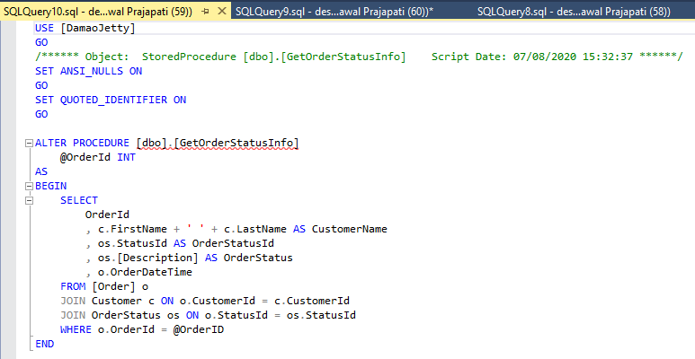

(Figure 12) Order Status Store Procedure

### 6.3.7 Cart Page

CSS Bootstrap table format is been used in this page to list the food items of the customers which they add the items in the cart. It will display the list of food items with its quantity and the food image and with its title. Customers are also able to remove any food items from the cart by clicking on the remove button given beside. (Appendix 10.7.7)

### 6.3.8 Payment Page

This page contains all the payment details, where customers fills their personal details and their card details to make the payment. On this page there are two payment section for payment, if the customer wishes to pay by card, he/she needs to fill out the card details and if they want to pay by cash, they have to fill out the cash section and place their order.

Store Procedure is written in the database to save the details of the payment for the customers. In this case it stores both payment details if the customer makes the payment with card or by the cash. (Appendix 10.7.8)

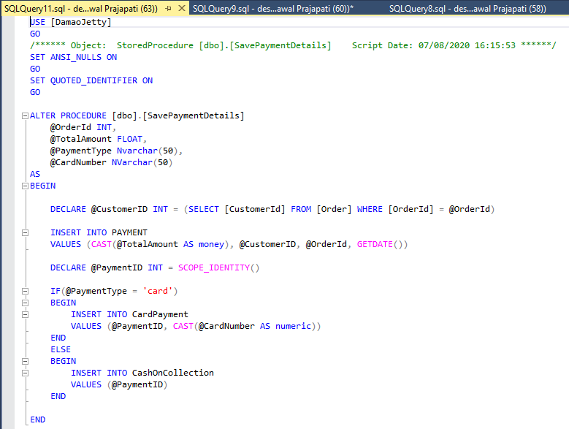

(Figure 13) Payment Store Procedure

### 6.3.9 Login

The user must proceed through the authentication process to reach the Admin page. When a user clicks on the webpage's admin icon, it will redirect to the user and password requesting logging page. As the user name and password are hardcoded in the program. (Appendix 10.7.9)

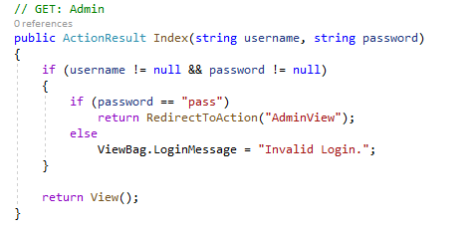

(Figure 14) Admin Login hardcoded

### 6.3.10 Admin Page

This page is only accessible by the Administrator of the business. The main aim of this page is, the admin can add the food items, change the order status of the customer’s order, change price of the menu, edit the existing food item description and delete the food items for the menu. Customers cannot access this page.

When the admin logs in to the Admin Page it will display him/her the whole table list of the food items. In the table of food list items there are also some links given like Edit, Add and Delete. So, by performing these operations the Admin can edit, add or delete the food item from the database which can also disappear form the website. (Appendix 10.7.10)

### 6.3.11 Add Food Item Page

In this page admin can add new food item to the menu, in this page there are fields where admin can add description of food, price, title and also upload the image from the device. (Appendix 10.7.11)

### 6.3.12 Edit Food Item Page

In this page admin can edit the existing food item from the menu, for example if the admin wants to change the price of the item or change in description of the food items. (Appendix 10.7.12)

### 6.3.13 Update Order Status Page

In this page admin can change the status of the ordered food by the customers, so when customers input their order number in search box, they can view their order status if pending, in progress or complete. (Appendix 10.7.13)

# **Chapter Seven: Evaluation**

## 7.1 Product Evaluation

Damao Jetty a food chain restaurant business website which is very famous and known for its famous food items. This website is very attractive, as it will attract the customers by their food images banner on the website. As this website consists of many features like slideshow of images, all the food items with their description and price, feedback section and a gallery page. There are also some additional element features like card and cash payment forms, order status button to track the orders of the customers, admin login page where only admin can login and customise the content or the menu and much more on the website. As all the requirements were meet to the implementation of this website, I am pretty sure that this website project is successful and in a very good manner.

In this project website the payment method form is designed with a validation feature, suppose if the customer fills out wrong details in the fields it will pass an alert stating to fill the appropriate details. For example, if the customer enters insufficient card number which is 11 digits rather than 16 digits it will ask the customer to fill a valid card number of details.

As I had a clear understanding and good interest in using of backend application with MY SQL and MSSQL for example of how to create tables, store the data, save data and quite familiar with writing queries. But I not had much (intermediate) experience in working with frontend applications. So, pursuing this project I accepted the responsibility of developing new knowledge that included frontend and collaboration with the backend database.

## 7.2 Approach

A very big thanks to the SDLC Agile approach, as I was managed to complete my project on time and successfully. I preceded the systemic approach and the SDLC Agile approach for implementation. Each project phase was within a specified time period, for example the very first approach for this project was doing a research, and second approach was prototype and third approach was doing development process followed by the documentation and report as the development phase was undertaken in Agile methodology.

As having a lack of experience of building the websites, the very first thing I did was listed all the steps to build a website and prepared a Gantt Chart to track the project progress. For such a purpose, I chose to bring a systemic approach for the project in order to be able to check back with each point. The very first approach of my project was doing a research on the websites applications which involves technology processes, design framework, development framework and system analysis. The second approach was establishing a design for the application and database, also took place some diagrams like ERD diagrams, and user interface diagrams. And finally, I started to implement my project frontend into MVC framework and lastly implemented database management system as backend.

While doing this project I came to learn many different implementation tools and languages and also learnt how to manage the project. The very first thing I learnt about is MVC .Net frame work for the development of the website, I have also learned from the MVC technology that how we can build the file structure and manage the code by separating Model, View and controller. Furthermore, designing and developing all these together in languages such as c #, JavaScript, HTML5, CSS was an incredible accomplishment for me.

## 7.3 Tools Evaluation

In this project I have used the C# language as a server-side scripting language which is very most use in asp.net. This also embraces the method to Object Oriented. I’ve the C# language as I was little familiar when I used in my previous Bachelors education. I have also utilised HTML5, JavaScript and CSS stylesheet to develop as frontend. JavaScript enables many important libraries like jQuery, Datatable, and CanvasJS.

Another major tool I used is MSSQL to build my database for this website application, using this backend tool was very interesting as I had good previous education experience from my Bachelors’. It was very interesting of using MSSQL to create the tables and writing and running the queries to build the database. I have also used many elements in the form of Bootstrap design elements which are very attracting features, and I have also used other tools like Draw.io, Creately to generate the diagrams of Use Case, Class Diagrams and ERD diagrams.

# **Chapter Eight: Conclusion & Recommendation**

## 8.1 Conclusion

In this project, website of ‘Damao Jetty ’restaurant I have covered almost all the key requirements which are necessary for website. This Restaurant Website allows the customer to place the order for food items, allows to perform the action to remove the food items from the cart, and when it comes to capture the details, the website also stores the information of the customer details, payment details and order details. The website also contains the features like rendering of images and video, it has a gallery page which contains attractive images and the home page contains a video of how the food is prepared at restaurant. Additionally, there is also an exciting feature which allows the customer to track their food order status just by navigating to the ‘Order Status’ page and entering their order numbers.

Overall, the project was completed successfully, but while pursuing this project I gained very deep understanding of C#, asp .Net, MVC technology, CSS3 and JavaScript. I also utilised my backend skills to build the Datawarehouse of this application which was very challenging to me. This project can have many additional features going forward like live chat recommendation, offer updates news, discount menu and much more. Having a website for the small restaurant businesses which only provide takeaway services is very beneficial for them to help out with customer orders.

By implementation on this website the knowledge what I have gained in not only on development side but I also gained knowledge on management side. But having a Gantt chart timeline of the project helped me a lot in managing the project. And finally I was able to able to successfully finish my project on schedule.

# **Reference**

AGRAWAL, S. et al. (2004) Database Tuning Advisor For Microsoft SQL Server 2005. In: In Proceedings of the VLDB 2004 Conference.

ALGHAMDI, A. (2012) Adopting User-Centred Development For Arabic E-commerce Websites. International journal of Web & Semantic Technology, 3(2), pp. 1–17.

AL-MASREE, H.K. (2015) Extracting Entity Relationship Diagram (ERD) From Relational Database Schem. International Journal of Database Theory and Application, 8(3), pp. 15–26.

ANTANAS, Ū. (2019) Consumer Loyalty Interfaces with Website Quality. Organizacijų Vadyba: Sisteminiai Tyrimai, 82(1), pp. 87–96.

BARBER, R. et al. Conference and Journal Notices. p. 63.

BENNETT, T. (2017) Marketing Strategies: How Small Restaurant Businesses use Social Media. Walden Dissertations and Doctoral Studies, [Online] Available from: https://scholarworks.waldenu.edu/dissertations/3429.

BERARDI, N., KATAWAZI, A. and BELLINASO, M. (2009) ASP.NET MVC 1.0 Website Programming: Problem - Design - Solution. John Wiley & Sons.

BIFET, A. et al. (2011) MOA: A Real-Time Analytics Open Source Framework. In: GUNOPULOS, D. et al. (eds.) Machine Learning and Knowledge Discovery in Databases. Lecture Notes in Computer Science. Berlin, Heidelberg: Springer Berlin Heidelberg, pp. 617–620.

BLAND, M.A. and NEPUSTIL, V. (1998) Management-data-gathering system for gathering on clients and servers data regarding interactions between the servers, the clients, and users of the clients during real use of a network of clients and servers.

BODHUIN, T., GUARDABASCIO, E. and TORTORELLA, M. (2002) Migrating COBOL systems to the Web by using the MVC design pattern. In: Ninth Working Conference on Reverse Engineering, 2002. Proceedings. Ninth Working Conference on Reverse Engineering. Richmond, VA, USA: IEEE Comput. Soc, pp. 329–338.

BOLCHINI, D. and PAOLINI, P. (2003) Mastering the Requirements Analysis for Communication-intensive Websites. p. 226.

CEBI, S. (2013) Determining importance degrees of website design parameters based on interactions and types of websites. Decision Support Systems, 54(2), pp. 1030–1043.

CHAUDHURI, S. and NARASAYYA, V. (1997) Efficient cost-driven index selection tool for microsoft sql server. In: In Proc. 1997 Intl. Conf. on Very Large Data Bases. pp. 146–155.

CORONEL, C., MORRIS, S. and ROB, P. (2013) Database systems: design, implementation, and management. 10e [edition]. Boston, MA: Course Technology/Cengage Learning.

DARIES, N. et al. (2018) Maturity and development of high-quality restaurant websites: A comparison of Michelin-starred restaurants in France, Italy and Spain. International Journal of Hospitality Management, 73, pp. 125–137.

DARIES-RAMON, N., CRISTOBAL-FRANSI, E. and MARINÉ-ROIG, E. (2019) Deployment of Restaurants Websites’ Marketing Features: The Case of Spanish Michelin-Starred Restaurants. International Journal of Hospitality & Tourism Administration, 20(3), pp. 249–280.

DEGELMAN, L. (2015) THE USE OF VIDEO-COMPUTER PRESENTATION TECHNIQUES TO AIS IN COMMUNICATION BETWEEN ARCHITECH AND CLIENT. College Of Architecture, Oct.

DRINGUS, P. (1997) EVALUATING WEB-BASED INSTRUCTION DESIGN. p. 47.

FLAVIAN, C., GURREA, R. and ORÚS, C. (2009) Web design: a key factor for the website success. Journal of Systems and Information Technology, 11(2), pp. 168–184.

GALITZ, W.O. (2007) The Essential Guide to User Interface Design: An Introduction to GUI Design Principles and Techniques. John Wiley & Sons.

GEVORGYAN, G. and PORTER, L.V. (2008) One Size Does Not Fit All: Culture and Perceived Importance of Web Design Features. Journal of Website Promotion, 3(1–2), pp. 25–38.

GROVES, R.M. et al. (2011) Survey Methodology. John Wiley & Sons.

HAMDANIA, H.A. (2019) Design and Implementation of Educational Application for Directorate of Traffic Safety, Oman. Journal of Student Research, [Online] Available from: https://jofsr.org/index.php/path/article/view/966 [Accessed 06/08/2020].

HASAN, L., MORRIS, A. and PROBETS, S. (2013) E‐commerce websites for developing countries – a usability evaluation framework. Online Information Review, 37(2), pp. 231–251.

HEJLSBERG, A., WILTAMUTH, S. and GOLDE, P. (2003) C# Language Specification. USA: Addison-Wesley Longman Publishing Co., Inc.

IMIELIŃSKI, T. and VIRMANI, A. (1999) MSQL: A Query Language for Database Mining. Data Mining and Knowledge Discovery, 3(4), pp. 373–408.

JARRETT, C. and GAFFNEY, G. (2009) Forms that Work: Designing Web Forms for Usability. Morgan Kaufmann.

KASSIM, N.M. and ABDULLAH, N.A. (2008) Customer Loyalty in e‐Commerce Settings: An Empirical Study. Electronic Markets, 18(3), pp. 275–290.

KIMES, S.E. (2008) The Role of Technology in Restaurant Revenue Management. Cornell Hospitality Quarterly, 49(3), pp. 297–309.

KOTHARI, C. (1990) Research Methodology C R Kothari. New Age International (P) Ltd., Publishers Published by New Age International (P) Ltd., Publishers, [Online] Available from: http://dl.saintgits.org/xmlui/bitstream/handle/123456789/1133/Research%20Methodology%20C%20R%20Kothari%20%28Eng%29%201.81%20MB.pdf?sequence=1&isAllowed=y.

KRASNER, G.E., POPE, S.T. and SYSTEMS, P. A Description of the Model-View-Controller User Interface Paradigm in the Smalltalk-80 System. p. 35.

KUAN, H.-H., BOCK, G.-W. and VATHANOPHAS, V. (2008) Comparing the effects of website quality on customer initial purchase and continued purchase at e-commerce websites. Behaviour & Information Technology, 27(1), pp. 3–16.

LETKOWSKI, J. (2005) Doing database design with MsSQL. p. 16.

LIANG, C.-J. and CHEN, H.-J. (2009) A study of the impacts of website quality on customer relationship performance. Total Quality Management & Business Excellence, 20(9), pp. 971–988.

LIM, S.H. (2013) Relationships between Customer Value and Performance : Focusing on Family Restaurant Websites. Journal of Information Technology Services, 12(1), pp. 215–227.

MACDONALD, M., MABBUTT, D. and FREEMAN, A. (2011) Pro ASP.NET 4 in VB 2010. Apress.

MACKEY, A. and GASS, S.M. (2015) Second Language Research: Methodology and Design. Routledge.

MANGER, C. (2010) ADVANTAGES AND DISADVANTAGES OF FRAMEWORK PROGRAMMING WITH REFERENCE TO YII PHP FRAMEWORK, GIDEON .NET FRAMEWORK AND OTHER MODERN FRAMEWORKS. p. 19.

MAZZOLENI, P., REMBERT, A.J. and SUBBIAN, K. (2015) System advisor for requirements gathering and analysis in web solutions.

MCGOVERN, J. (2003) Business Logic Layer - an overview | ScienceDirect Topics. Available from : https://www.sciencedirect.com/topics/computer-science/business-logic-layer [Accessed 06/08/20].

MCKEOWN, B. and THOMAS, D.B. (2013) Q Methodology. SAGE Publications.

MINORE, L., YUKNEWICZ, P.J. and LASKER, S.M. (54) DATA ACCESS LAYER DESIGN AND CODE. p. 14.

MIRANDA, F.J., RUBIO, S. and CHAMORRO, A. (2015) The Web as a Marketing Tool in the Spanish Foodservice Industry: Evaluating the Websites of Spain’s Top Restaurants. Journal of Foodservice Business Research, 18(2), pp. 146–162.

MOHAMMAD, A., GHWANMEH, S. and AL-IBRAHIM, A. (2013) Enhanced Framework for Building Successful Website for Informative Companies. International Journal of Computer Applications, 78(3), pp. 1–7.

MOIR, T. (2018) Why Is Implementation Science Important for Intervention Design and Evaluation Within Educational Settings? Frontiers in Education, 3, [Online] Available from: doi.org/10.3389/feduc.2018.00061 [Accessed 07/08/2020].

NORMAN, M. (2006) Database Design Manual: using MySQL for Windows. Springer Science & Business Media.

PENG, C. (2011) Do Social Networking Websites Play a Part in Generation Y&#8217;s Dining Information Search and Sharing? An Examination of Consumer Characteristics. The Ohio State University.

PH.D, R.S. and BOROVICKA, M. (2007) Developing A Model for Supporting Quality in Restaurant Websites. Journal of Foodservice Business Research, 10(1), pp. 51–76.

POWELL, T. (2002) Web Publishing 3 Site Design & Usability UCSD Extension. PINT Inc, [Online]

PRABOWO, D. (2015) WEBSITE E-COMMERCE MENGGUNAKAN MODEL VIEW CONTROLLER ( MVC ) DENGAN FRAMEWORK CODEIGNITER Studi Kasus : Toko Miniatur. Data Manajemen dan Teknologi Informasi (DASI), 16(1), p. 23.

QI, S., YANG, F. and LI, C. (2013) An Exploratory Study on Restaurant Review Websites. In: XIANG, Z. and TUSSYADIAH, I. (eds.) Information and Communication Technologies in Tourism 2014. Cham: Springer International Publishing, pp. 355–365.

RAYFIELD, J. (2001) Web-application development using the Model/View/Controller design pattern - IEEE Conference Publication. Available from : https://ieeexplore.ieee.org/abstract/document/950428 [Accessed 06/08/20].

ROK, Z. (2000) Analysis of Object Persistence Frameworks in the .NET Framework - ProQuest. Available from : https://search.proquest.com/openview/6de52c25d4c8269f821fa2723320fded/1?pq-origsite=gscholar&cbl=1986354 [Accessed 07/08/20].

SALAS-ZÁRATE, M. DEL P. et al. (2015) Analyzing best practices on Web development frameworks: The lift approach. Science of Computer Programming, 102, pp. 1–19.

SARKER, I.H. and APU, K. (2014) MVC Architecture Driven Design and Implementation of Java Framework for Developing Desktop Application. International Journal of Hybrid Information Technology, 7(5), pp. 317–322.

SHIRAZI, H., HAEFNER, K. and RAY, I. (2017) Fresh-Phish: A Framework for Auto-Detection of Phishing Websites. In: 2017 IEEE International Conference on Information Reuse and Integration (IRI). 2017 IEEE International Conference on Information Reuse and Integration (IRI). San Diego, CA: IEEE, pp. 137–143.

STONE, D. et al. (2005) User Interface Design and Evaluation. Elsevier.

SUCURI (2019) Website Security: How to Secure & Protect Your Website. [Online] Sucuri. Available from : https://sucuri.net/guides/website-security/ [Accessed 21/07/20].

TARAL, P. and GITE, B. (2014) CMS Website Security Threat Protection Oriented Analyzer System. International Journal of Computer Applications Technology and Research, 3(12), pp. 809–811.

UNITED STATES and UNITED STATES (eds.) (2006) Research-based web design & usability guidelines. Version 2. Washington, D.C: U.S. Dept. of Health and Human Services : U.S. General Services Administration.

UPADHYAY, D. (2018) 7 Popular Website Development Frameworks of 2018 - DZone Web Dev. [Online] dzone.com. Available from : https://dzone.com/articles/7-most-popular-website-development-frameworks-of-2 [Accessed 07/07/20].

WEIKUM, G. et al. Data Engineering.

YARGER, R.J. et al. (1999) MySQL and mSQL. 1st ed. USA: O’Reilly & Associates, Inc.

YOUNG NAMKUNG MS, P., RD, SEO-YOUNG SHIN PHD, R. and IL-SUN YANG PHD, R. (2007) A Grounded Theory Approach to Understanding the Website Experiences of Restaurant Customers. Journal of Foodservice Business Research, 10(1), pp. 77–99.

# **Appendices**

## 10.1 Appendix 1 - UI Diagrams (User Interface)

**Home Page**

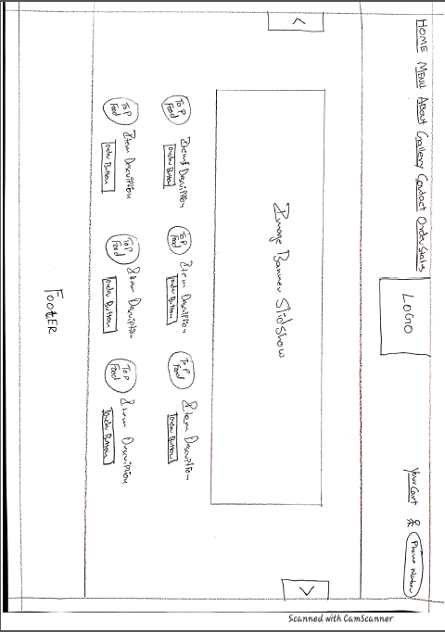

**Menu Page**

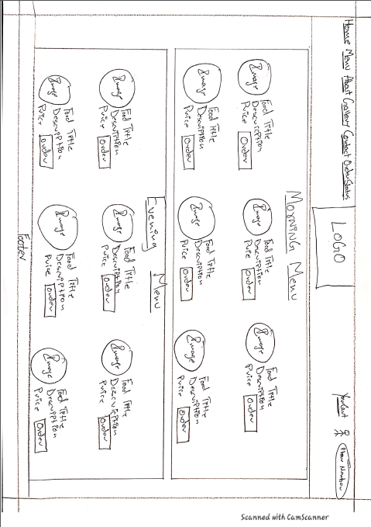

**About Page**

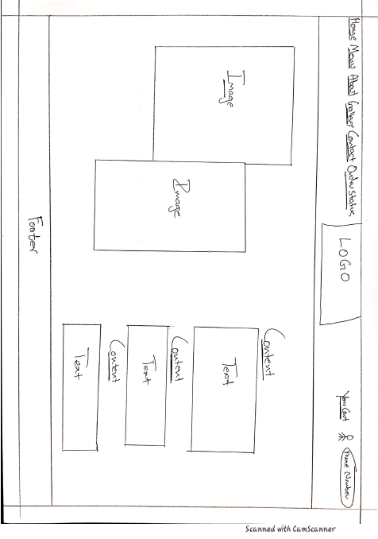

**Gallery Page**

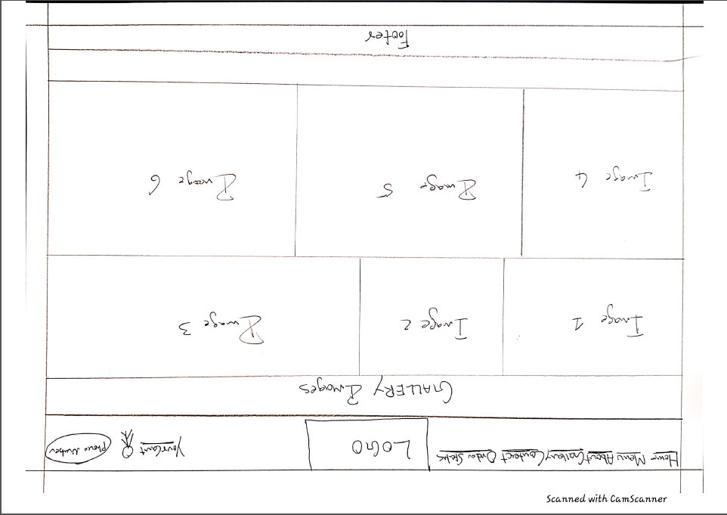

**Contact Page**

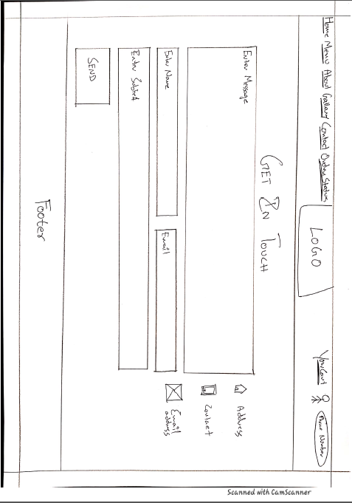

**Order Status Page**

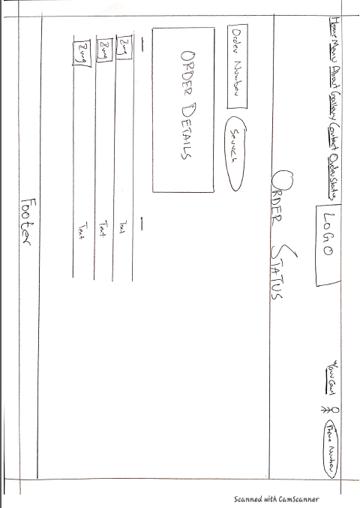

**Cart Page**

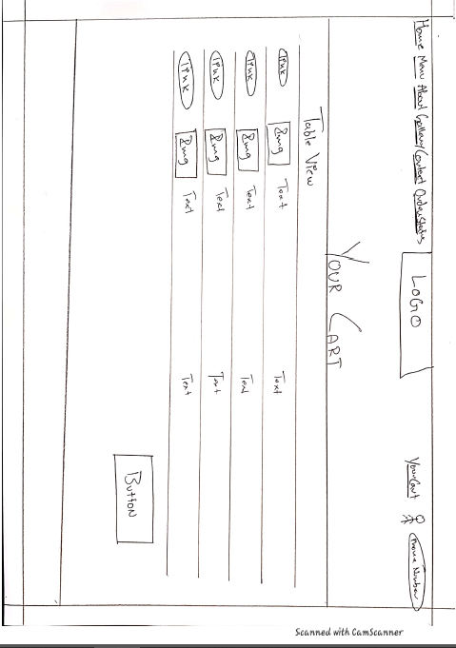

**Login Page**

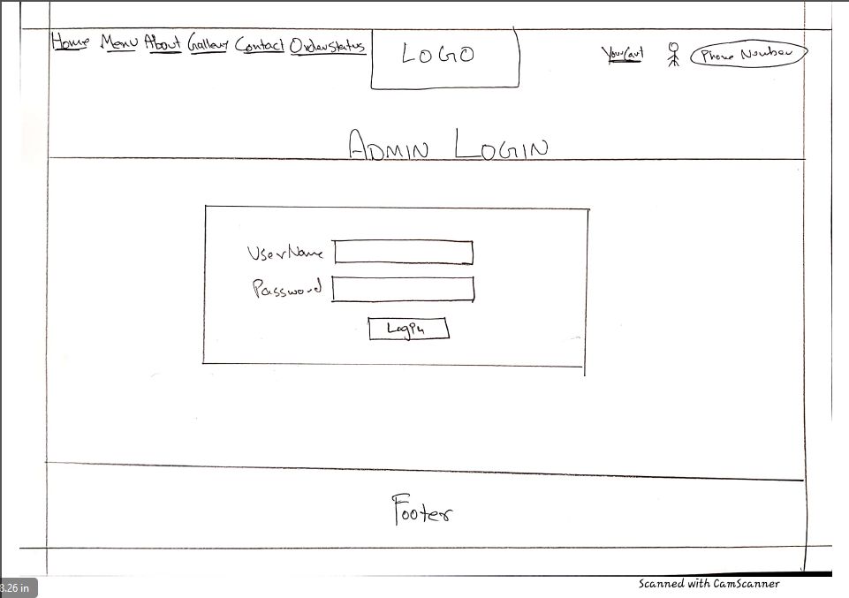

**Payment Page**

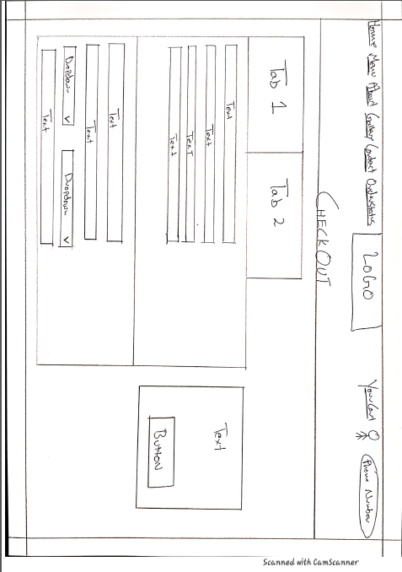

**Admin Page**

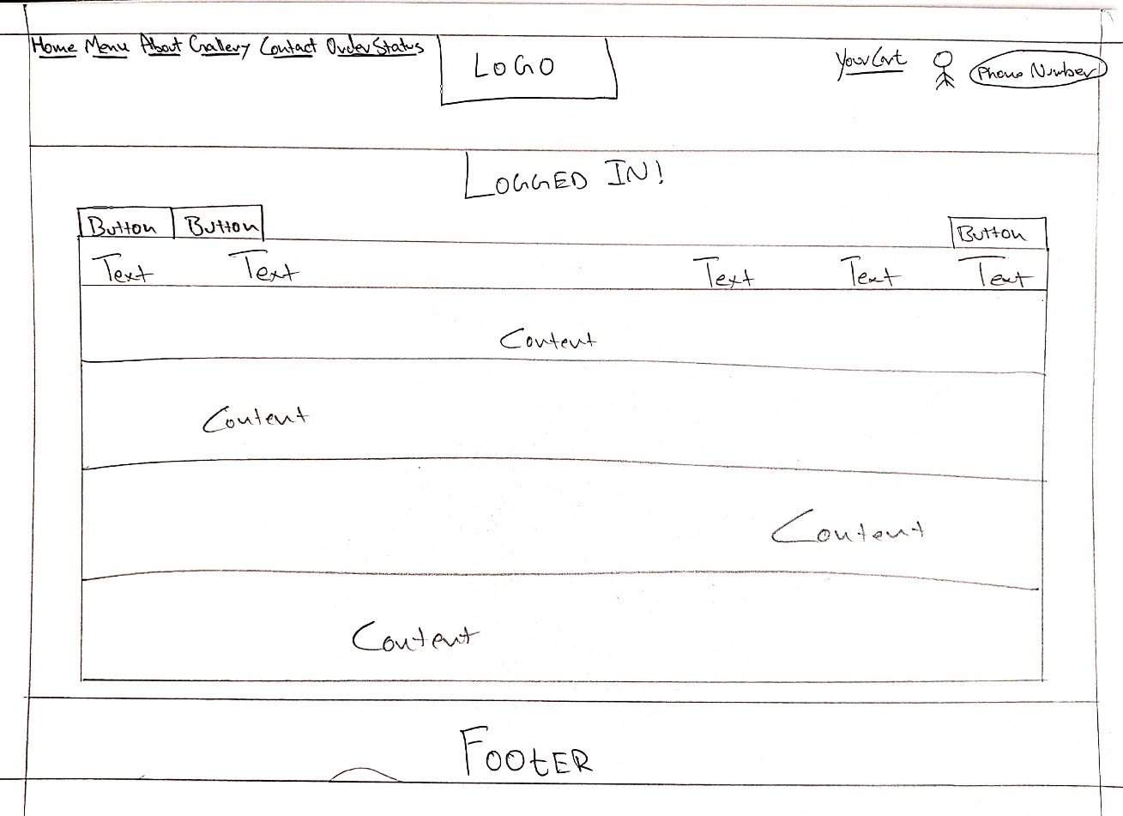

## 10.2 Appendix 2 - ERD Diagram

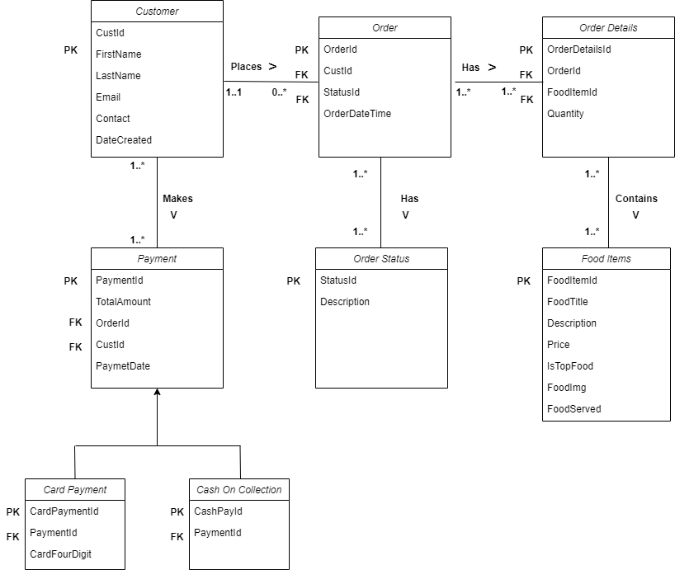

## 10.3 Appendix 3 - Class Diagram

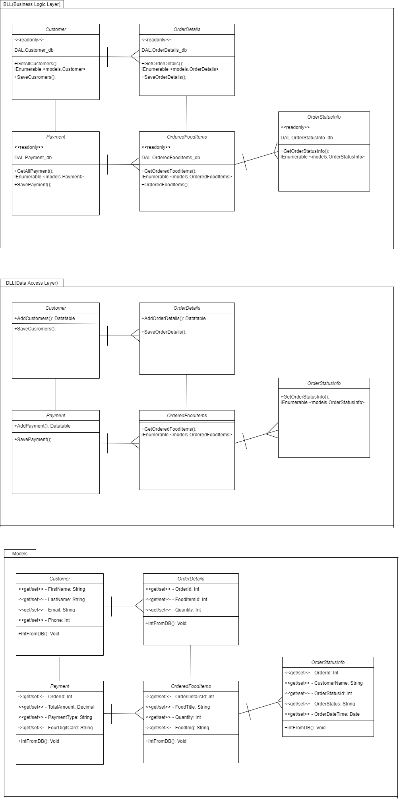

## 10.4 Appendix 4 - Use Case Diagram

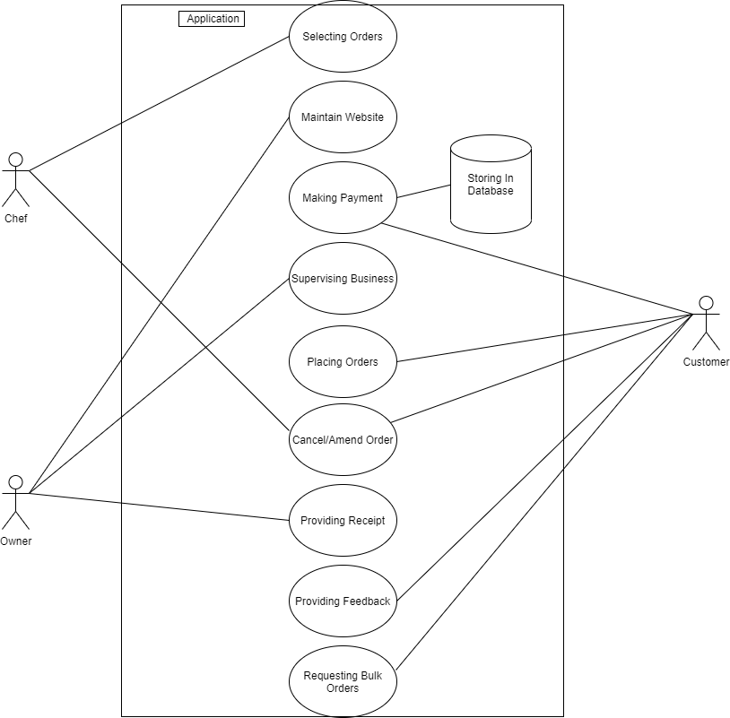

## 10.5 Appendix 5 – Requirements

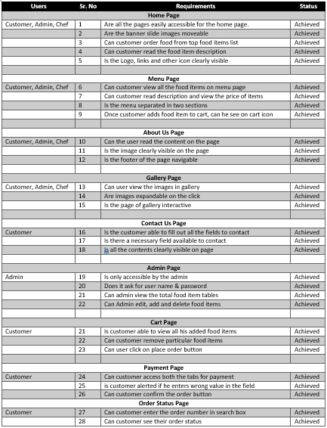

## 10.6 Appendix 6 – Database Implementation

### 10.6.1 Database Structure

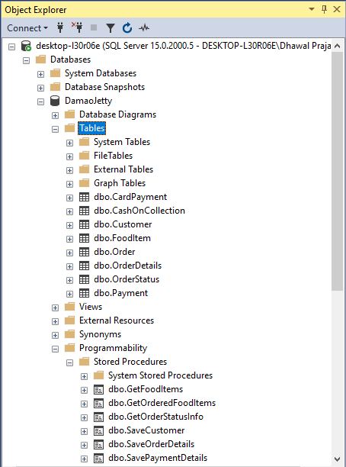

### 10.6.2 Customer Table

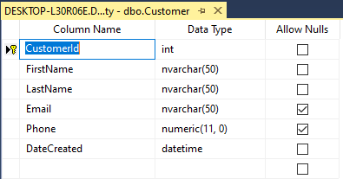

Create Table Query

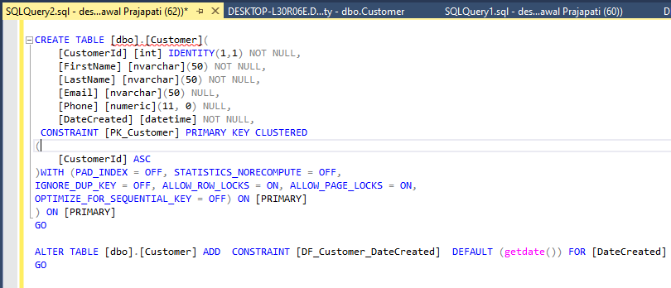

Store Procedure



### 10.6.3 Order Table

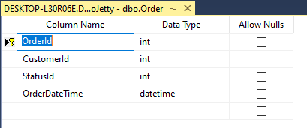

Create Table Query

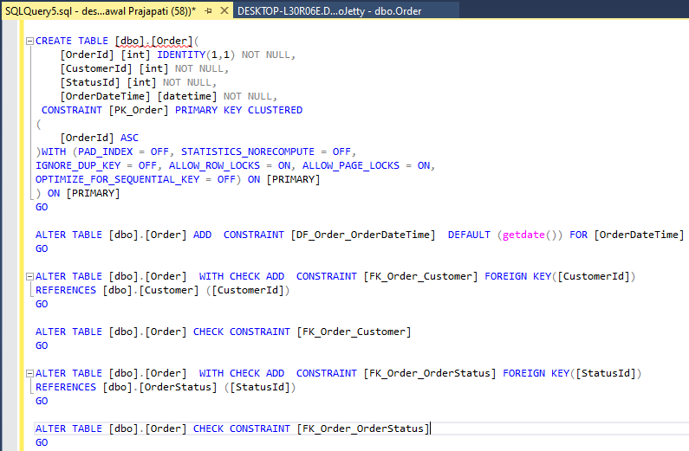

Store Procedure

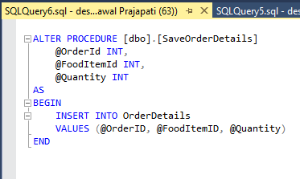

### 10.6.4 Food Items Table

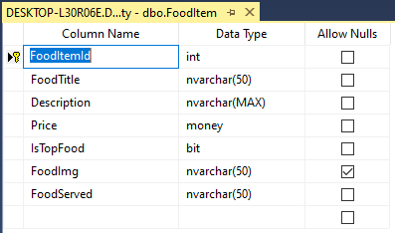

Create Table Query

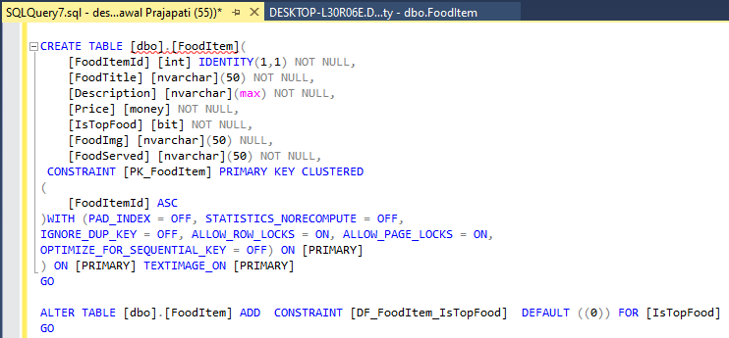

Store Procedure

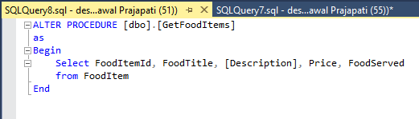

### 10.6.5 Payment Table

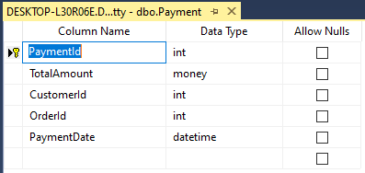

Create Table

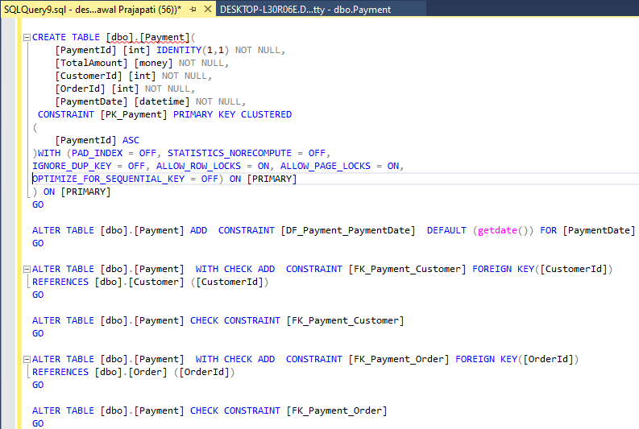

Store Procedure

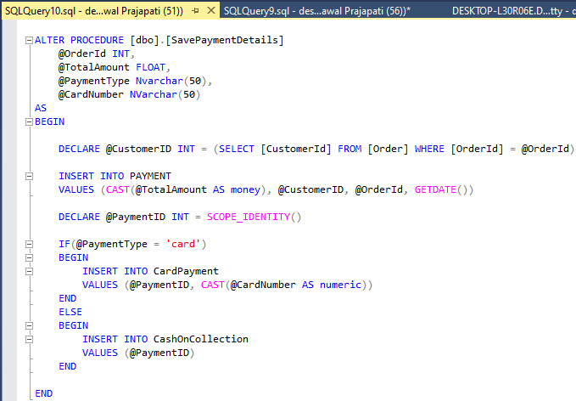

### 10.6.6 Order Details Table

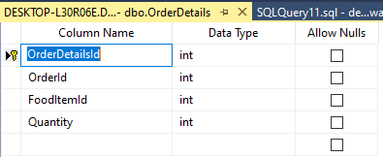

Create Table Query

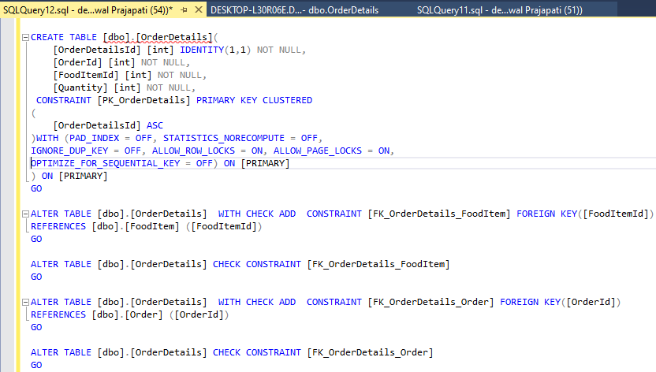

Store Procedure

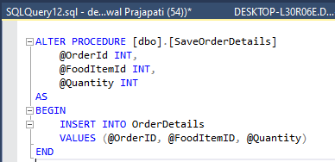

### 10.6.7 Order Status Table

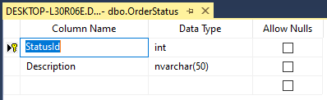

Create Table Query

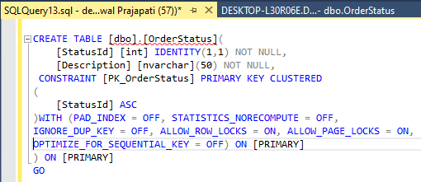

Store Procedure

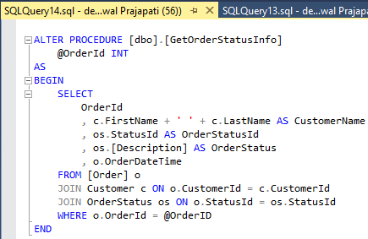

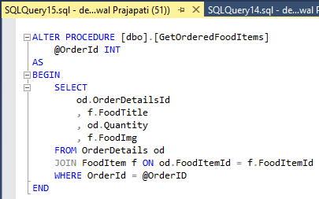

### 10.6.8 Card Payment Table

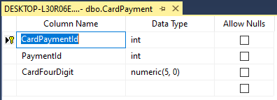

Create Table Query

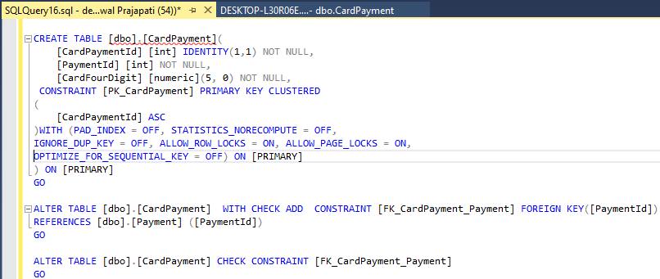

### 10.6.9 Cash on Collection Table

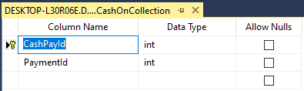

Create Table Query

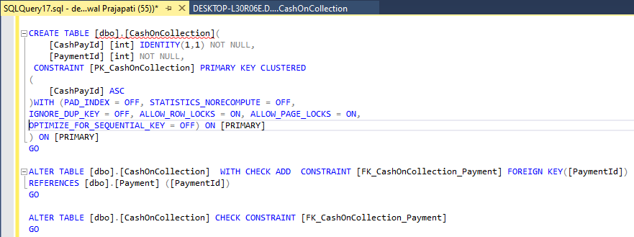

## 10.7 Appendix 7 – Web Pages Implemented

### 10.7.1 Home Page

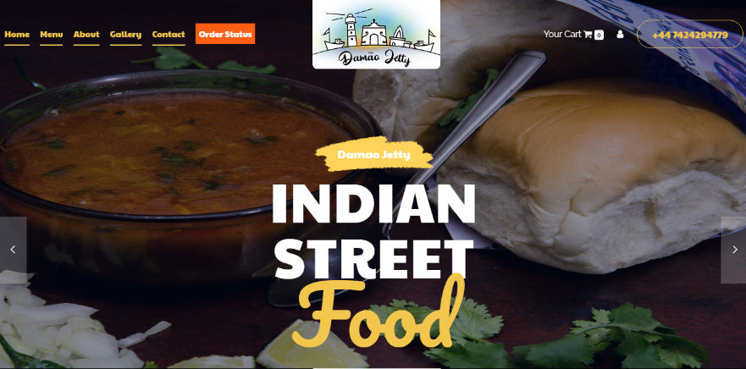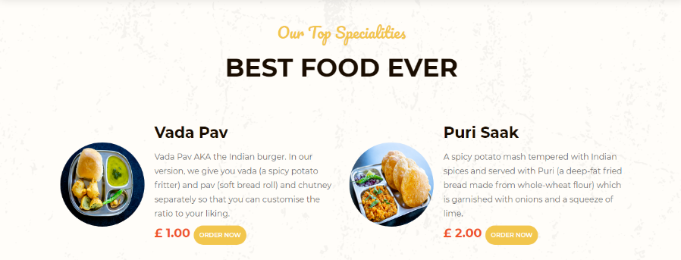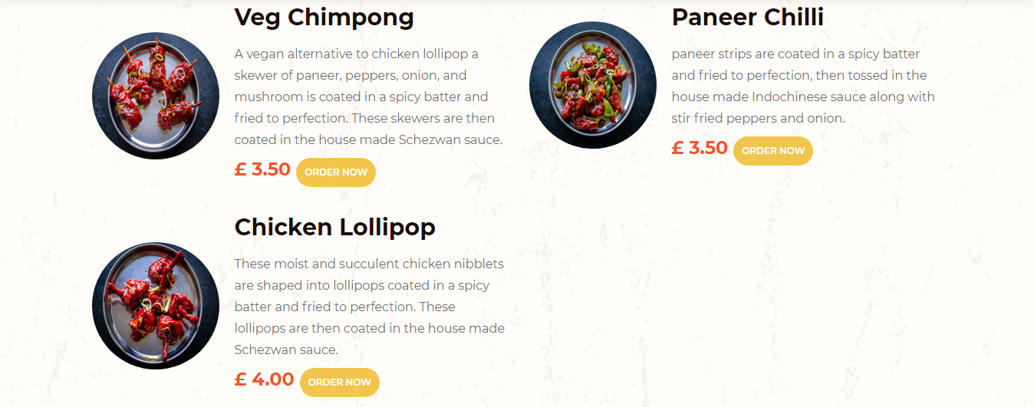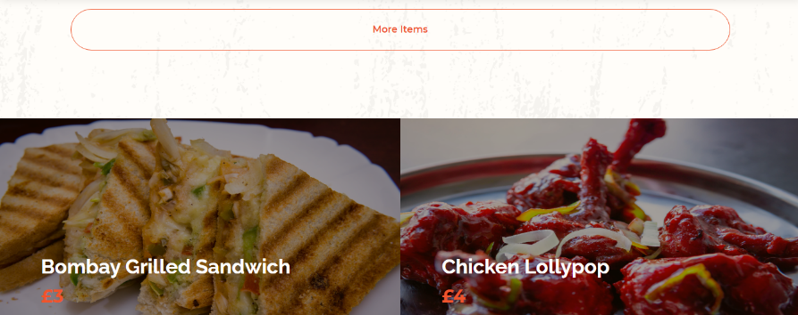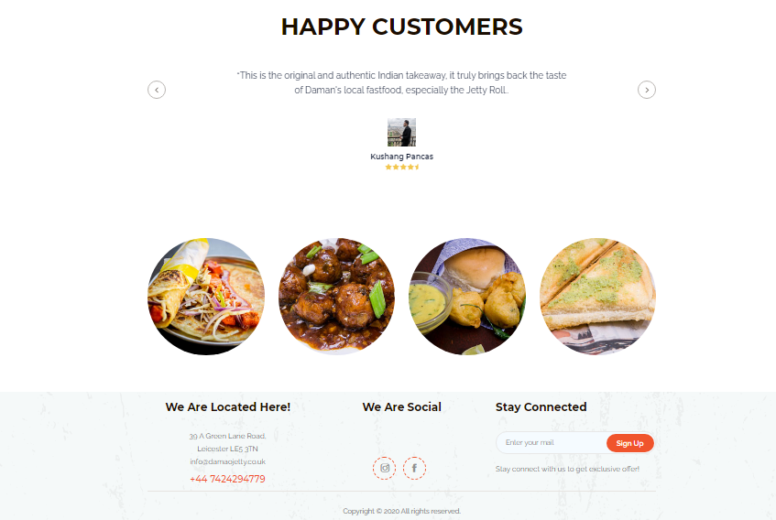

### 10.7.2 Menu Page

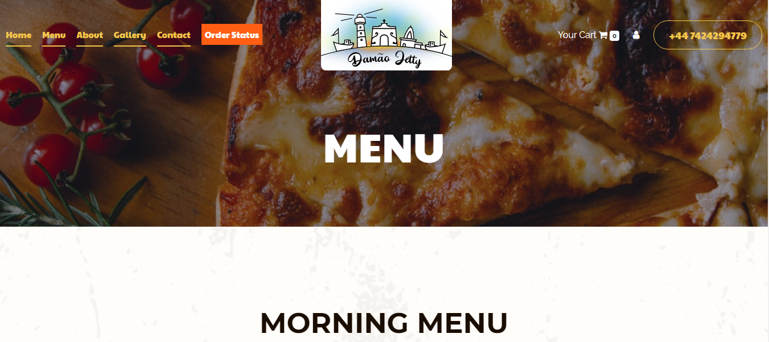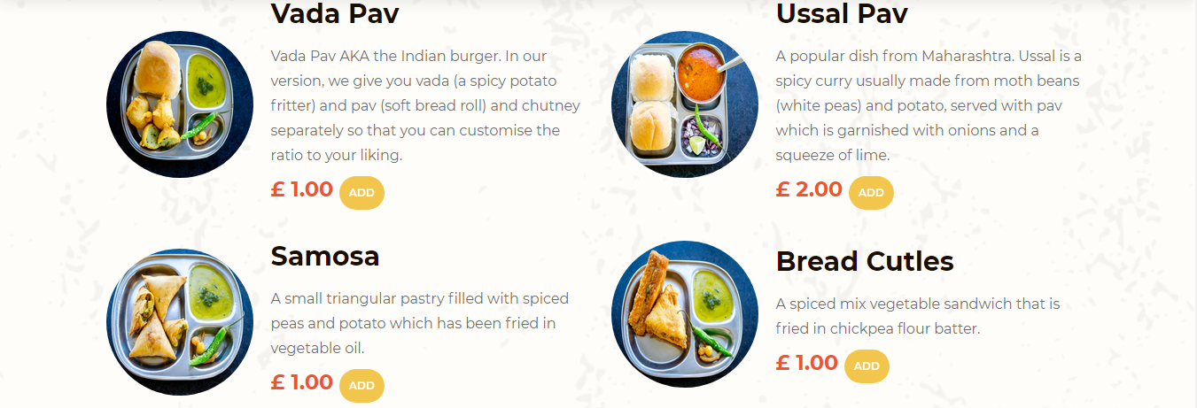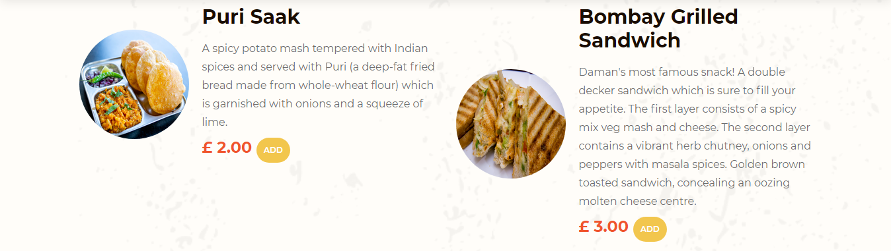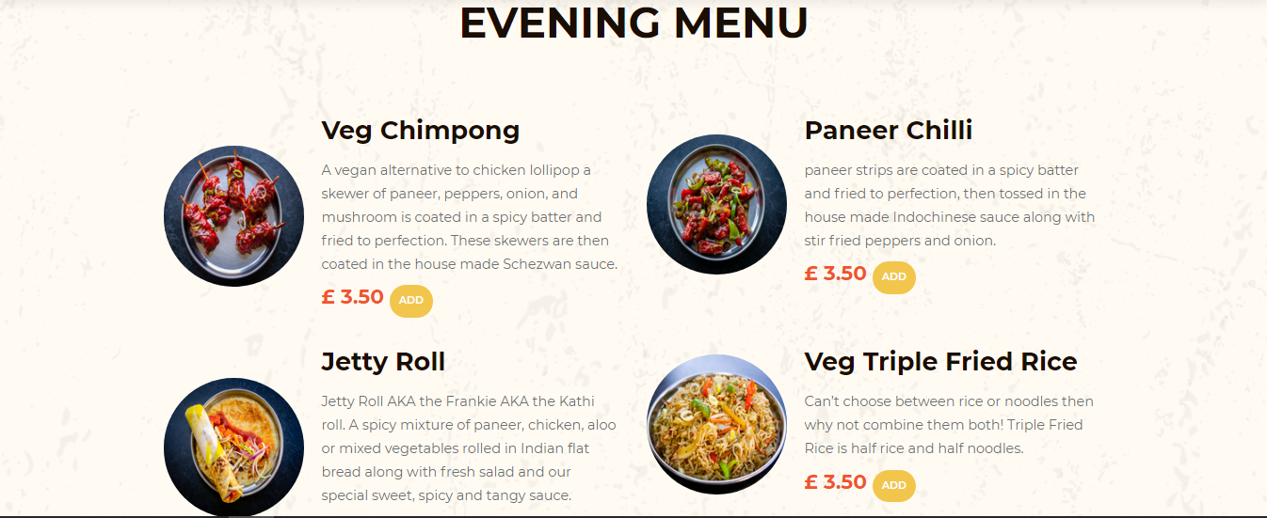

### 10.7.3 About Page

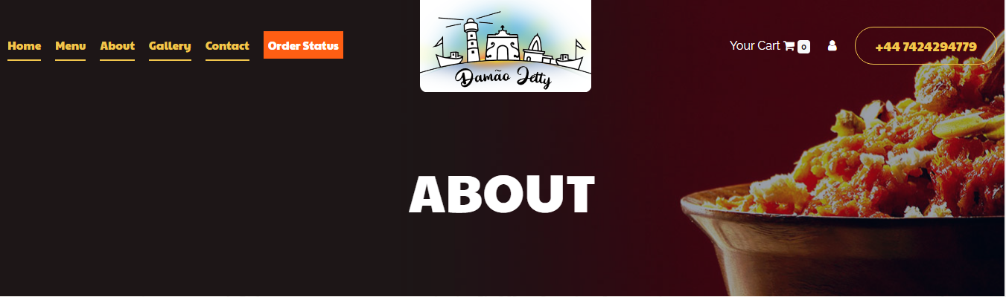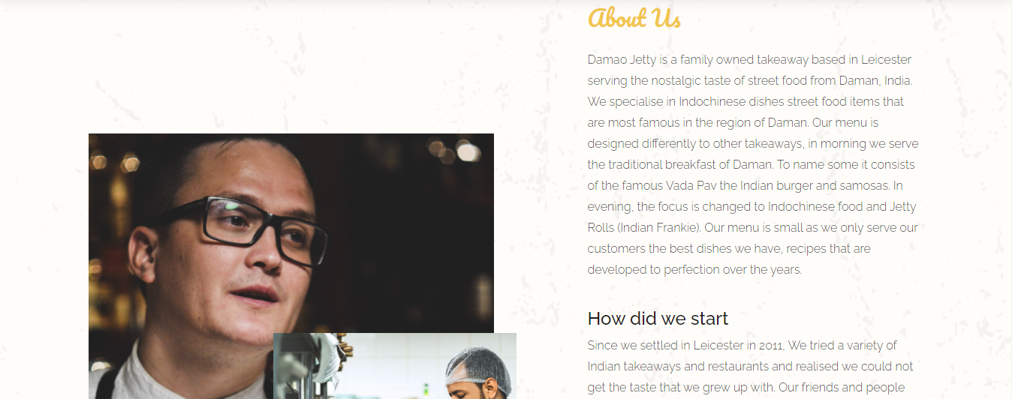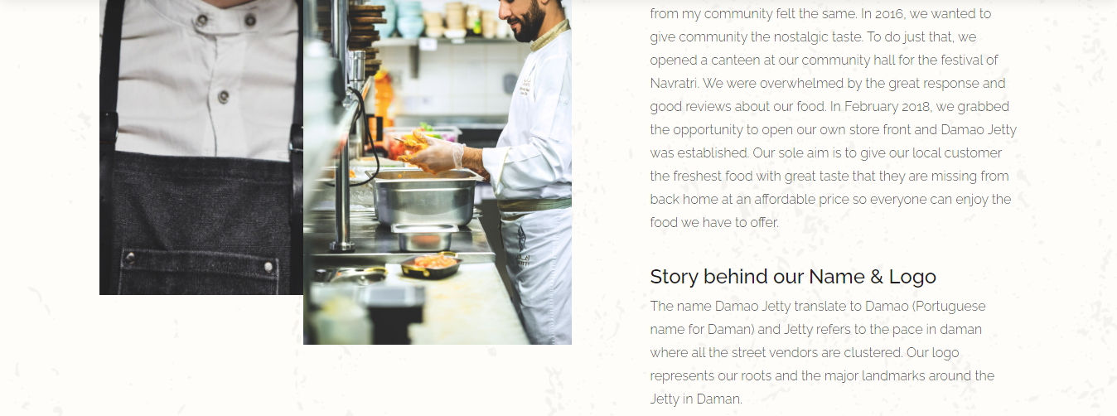

### 10.7.4 Gallery Page

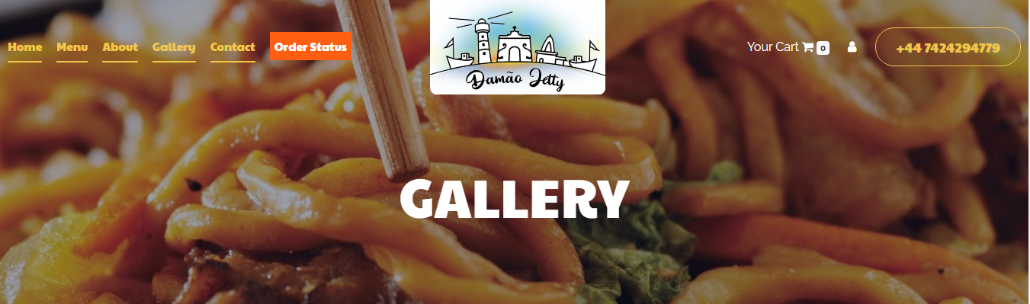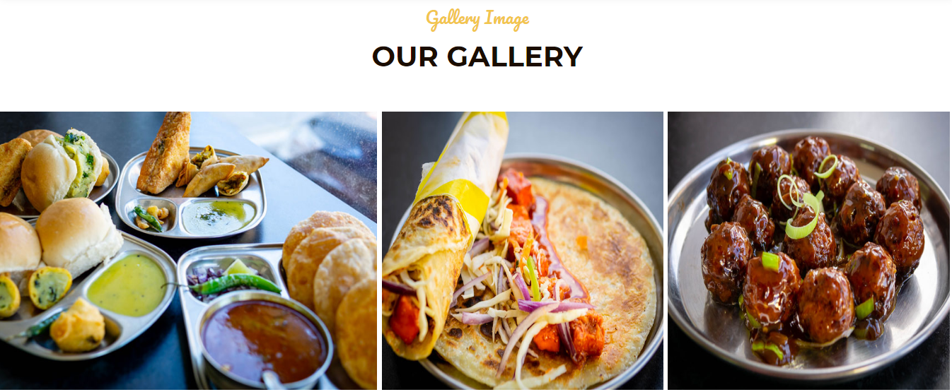

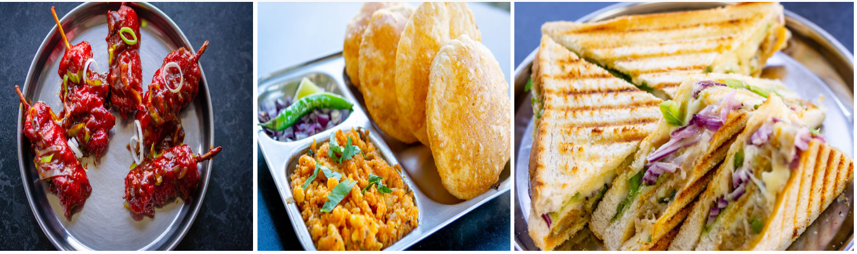



### 10.7.5 Contact Page

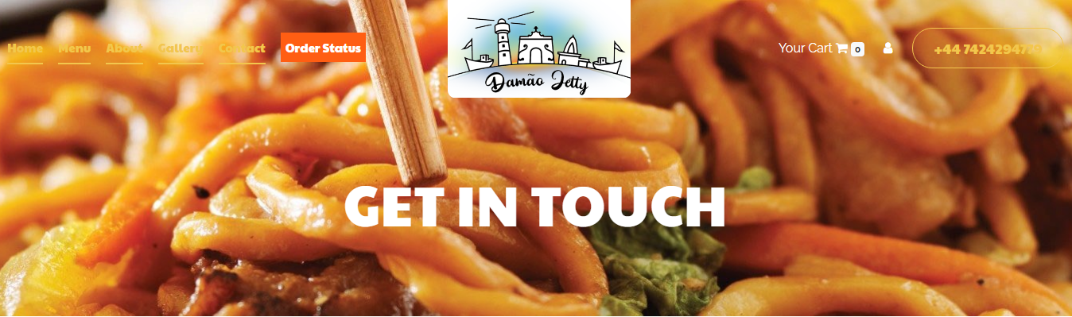

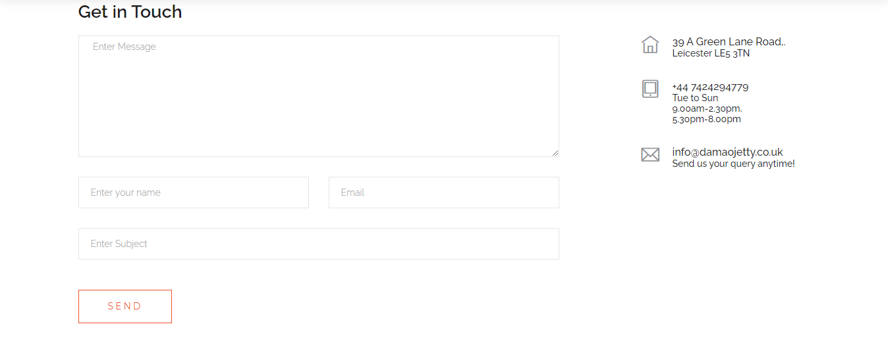



### 10.7.6 Order Status Page

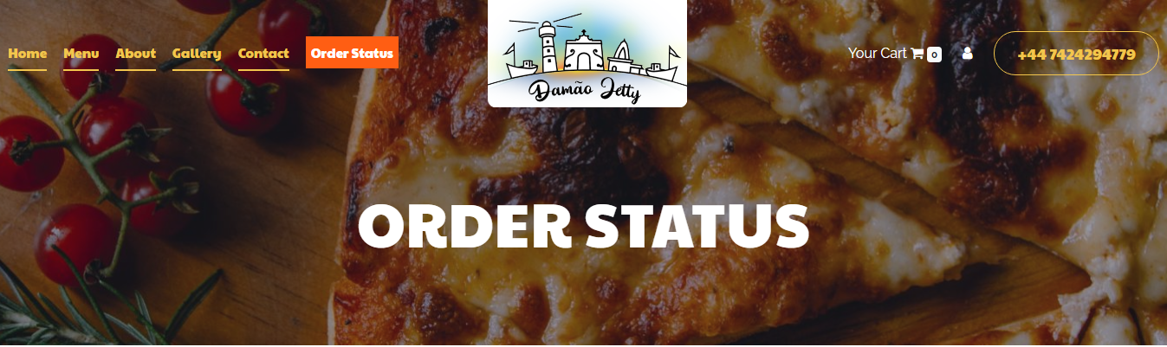

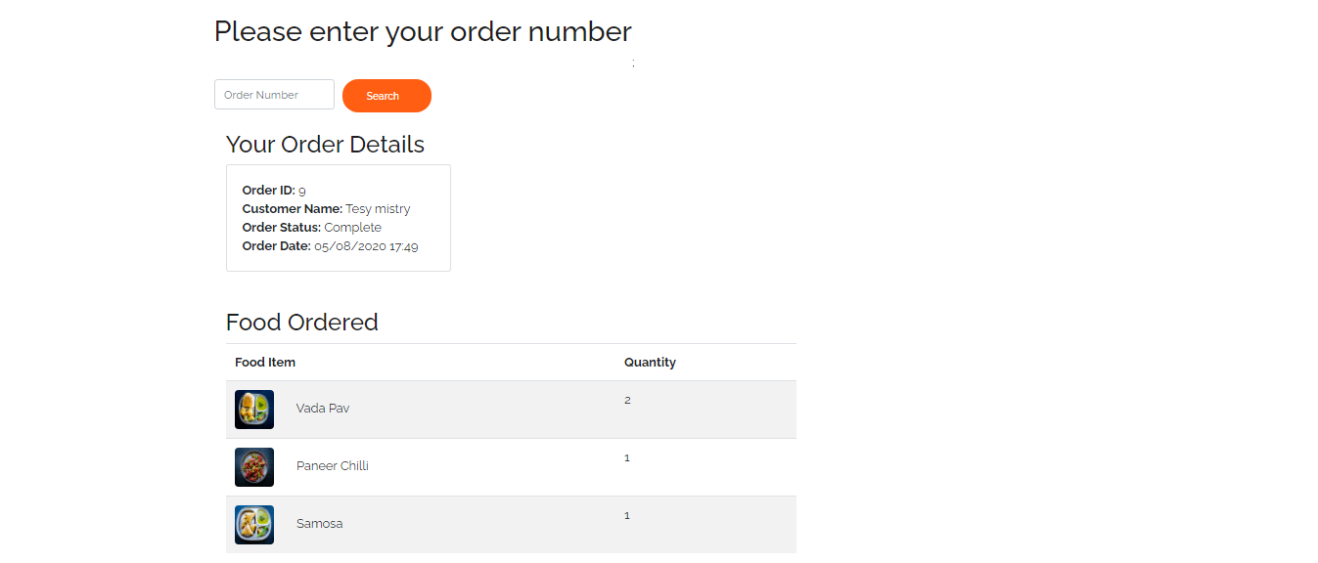



### 10.7.7 Cart Page

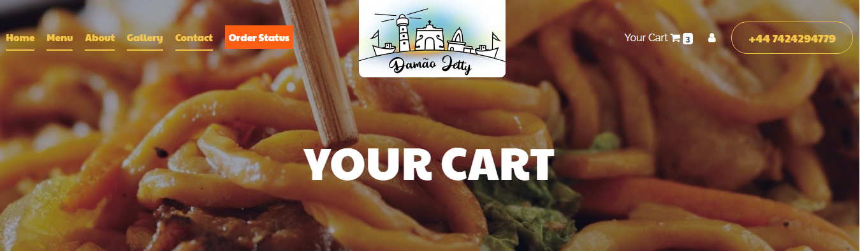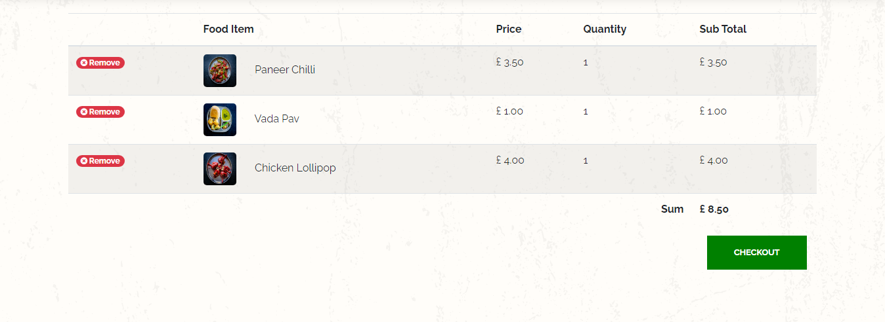

### 10.7.8 Payment Page

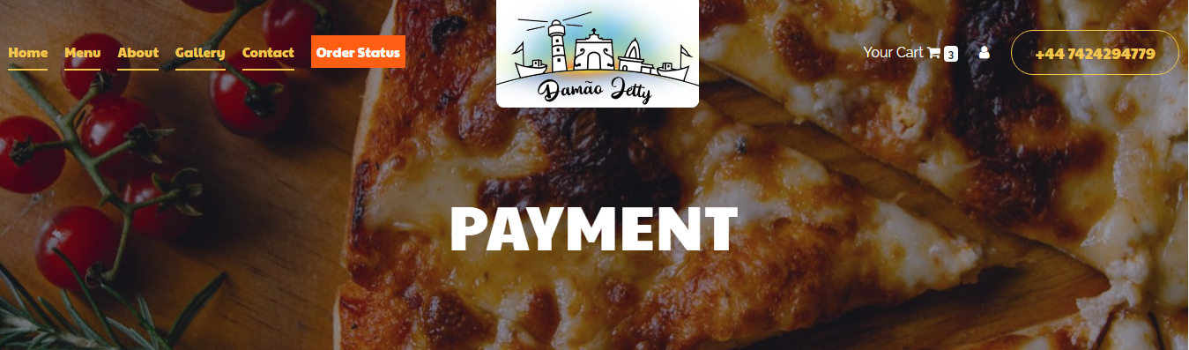

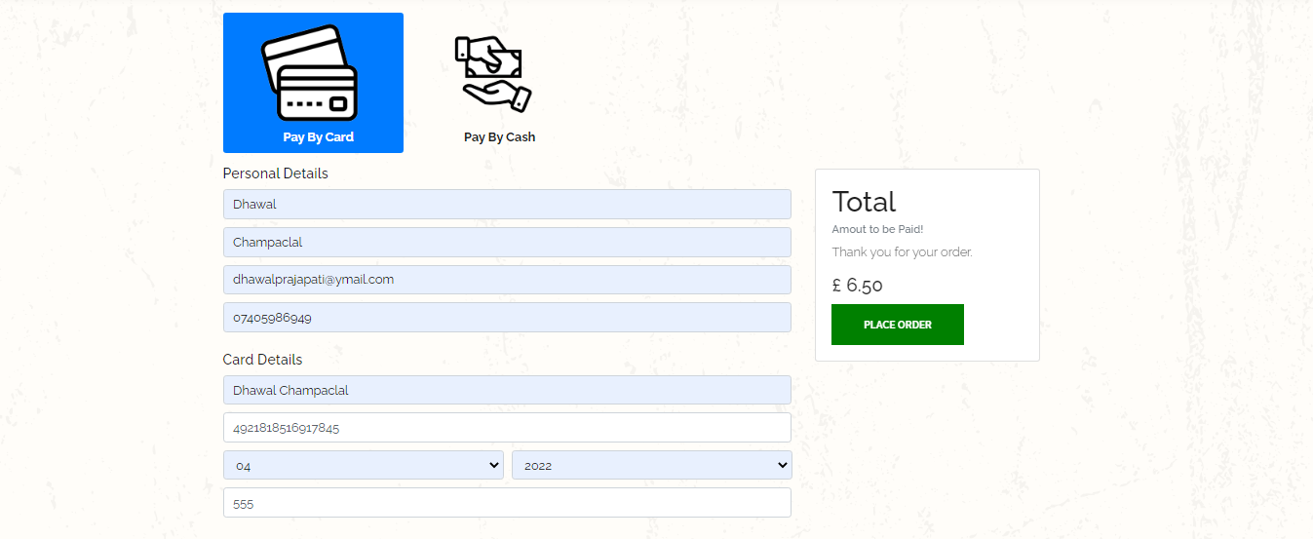



### 10.7.9 Login Page

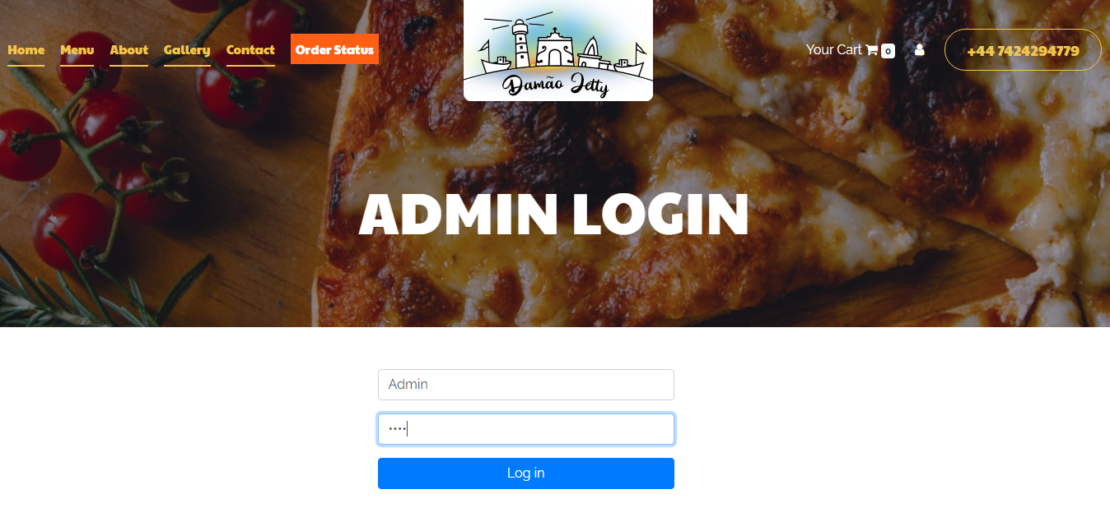



### 10.7.10 Admin View Page(Add/Edit/Remove Menu Items)

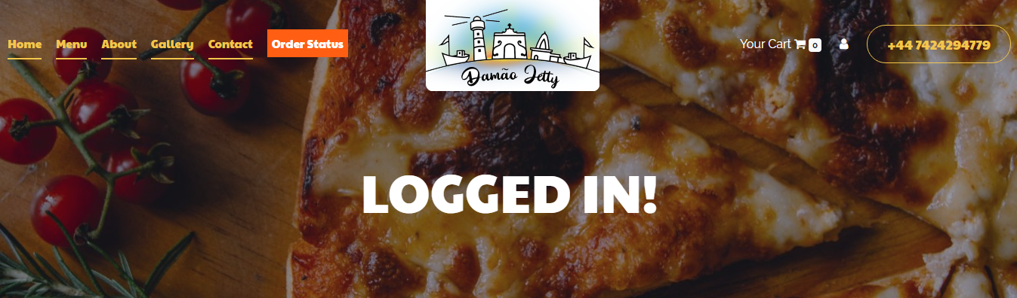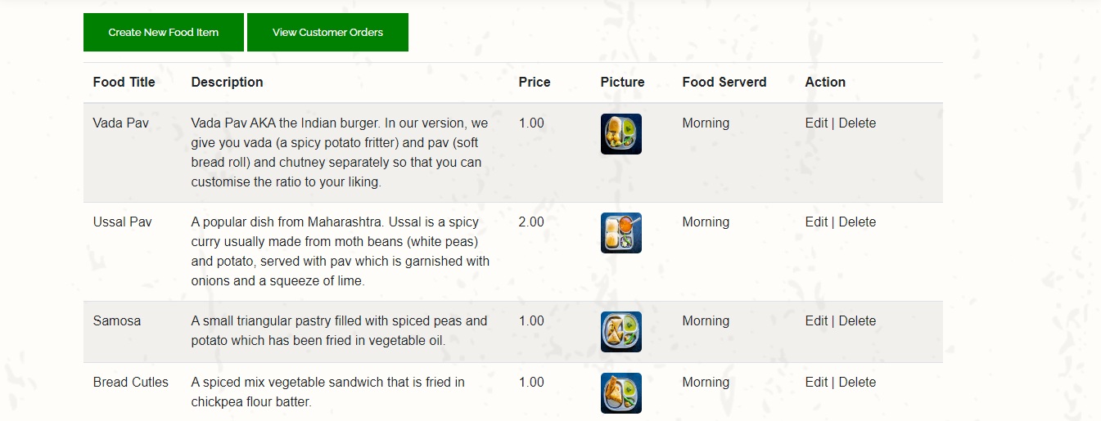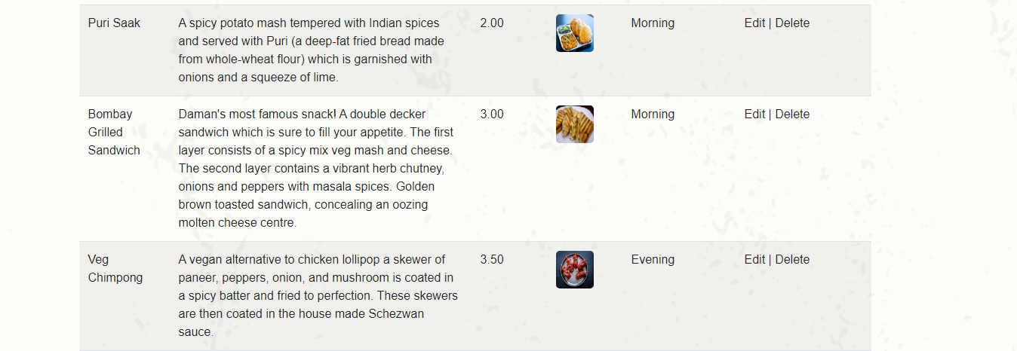



### 10.7.11 Add Food Item Page

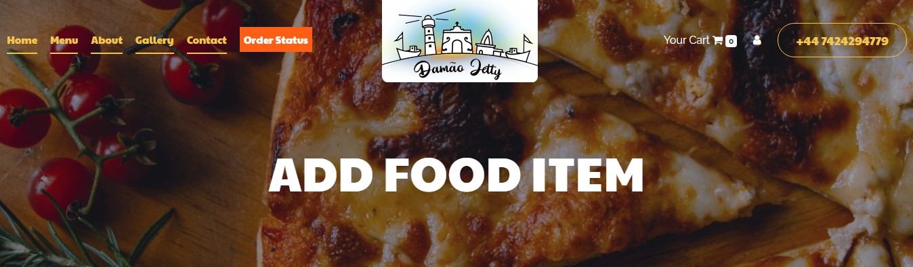

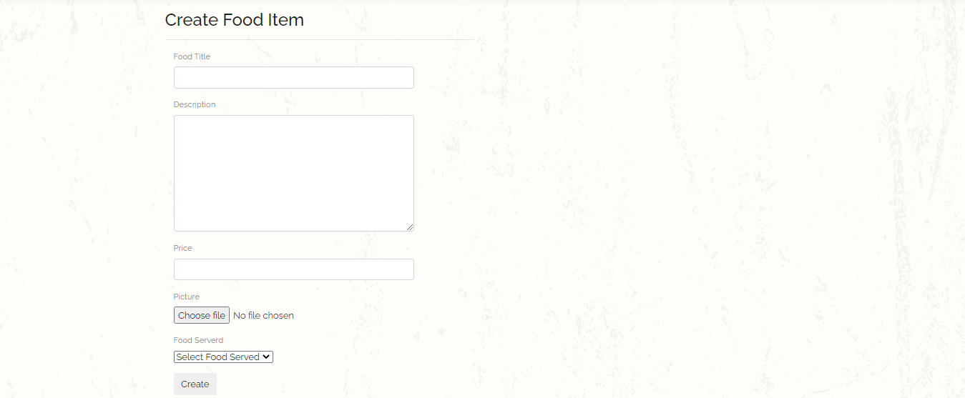



### 10.7.12 Edit Food Item Page

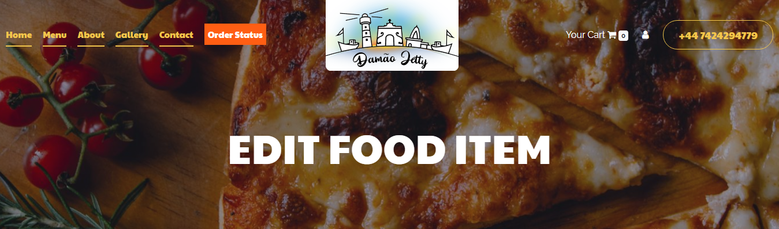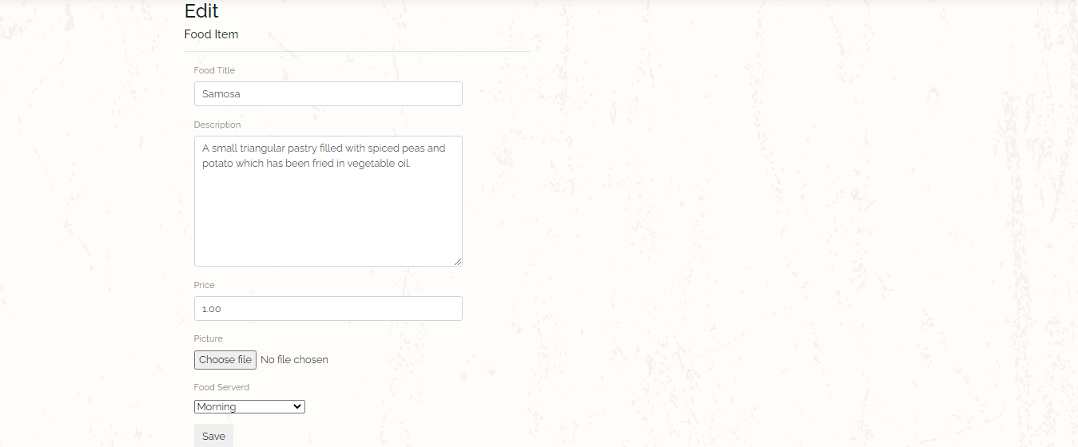



### 10.7.13 Order Status Update Page

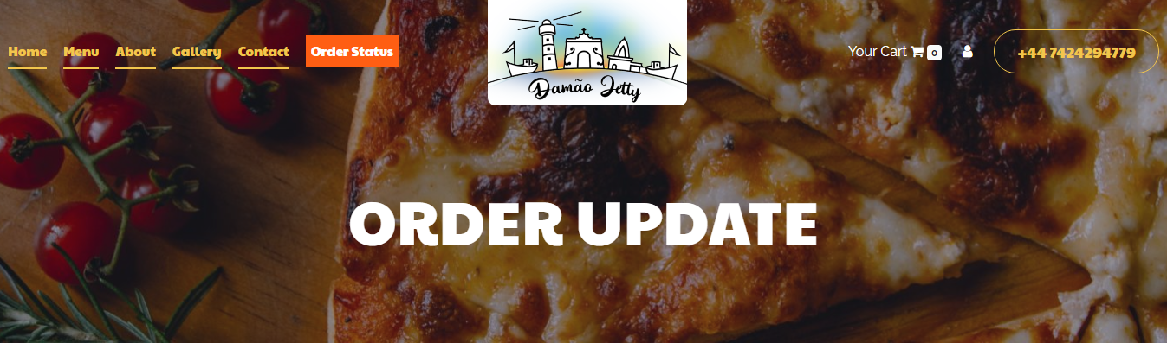

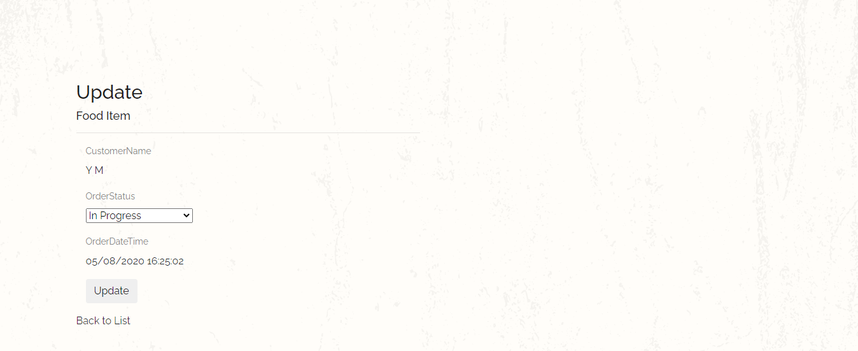



# **Progress Reports**

## 11.1 Report - 1

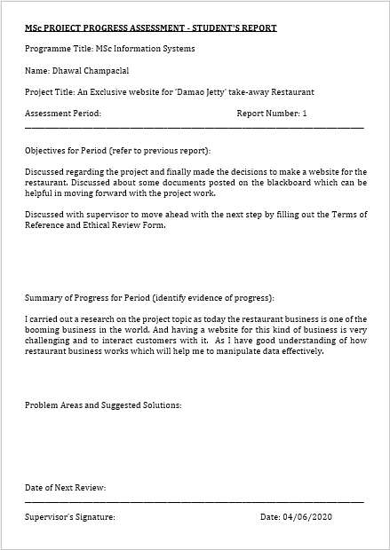

## 11.2 Report - 2

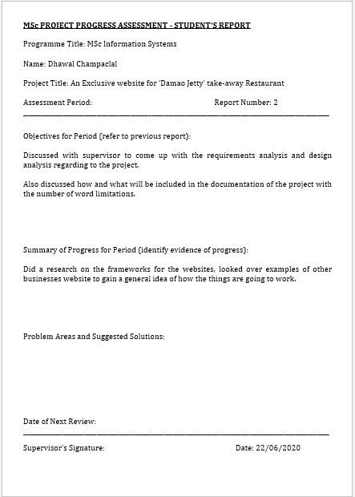

## 11.3 Report - 3

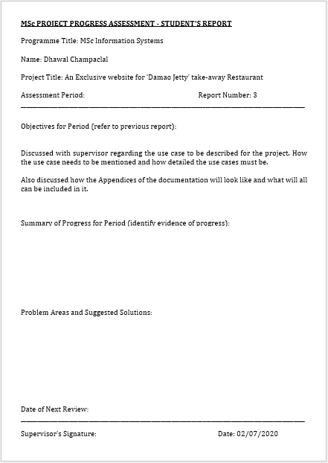

## 11.4 Report - 4

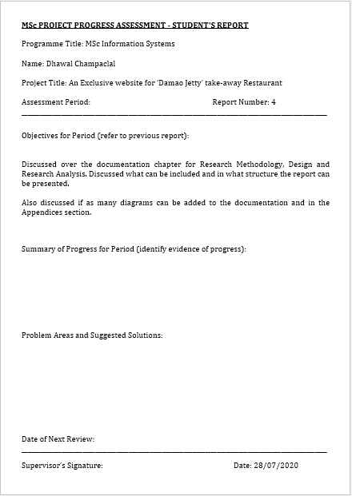

# **GitHub Logs**

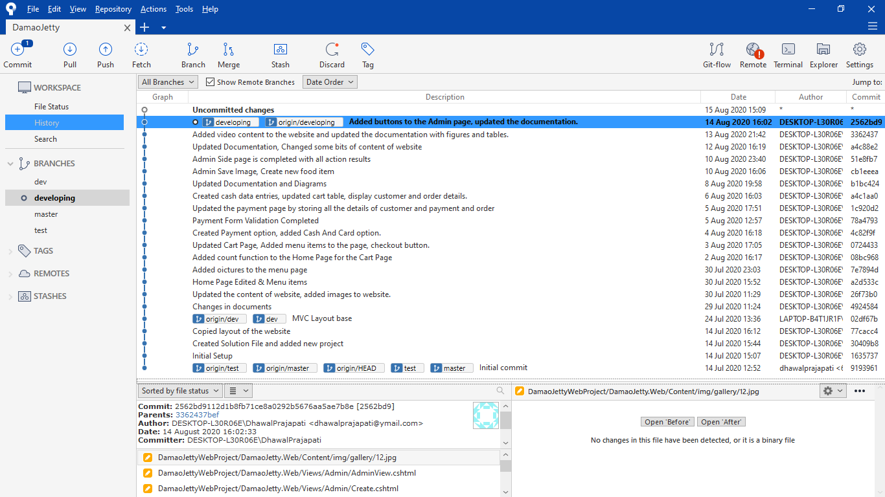

# **Gantt Chart**

**Schedule of Activities**

|  |  |  |  |  |
| --- | --- | --- | --- | --- |
| Sr. No | Task Description | Start Date | Finish Date | Duration |
| 1 | Installing Updated Software’s & updated windows | 02/06/2020 | 03/06/2020 | 1 |
| 2 | 1st meeting with supervisor | 03/06/2020 | 04/06/2020 | 1 |
| 3 | Completing Terms of Reference & Ethic form | 04/06/2020 | 09/06/2020 | 5 |
| 4 | 2nd meeting with supervisor | 09/06/2020 | 10/06/2020 | 1 |
| 5 | 1st meeting with the client | 09/06/2020 | 10/06/2020 | 1 |
| 6 | Gathering requirements from client for the project | 10/06/2020 | 11/06/2020 | 1 |
| 7 | Writing the introduction part | 11/06/2020 | 13/06/2020 | 2 |
| 8 | Acquiring References | 13/06/2020 | 14/06/2020 | 1 |
| 9 | 3rd meeting with supervisor | 13/06/2020 | 14/06/2020 | 1 |
| 10 | Writing background and Literature review of project | 14/06/2020 | 16/06/2020 | 2 |
| 11 | Writing on research methodologies | 16/06/2020 | 18/06/2020 | 2 |
| 12 | Creating templates of website | 18/06/2020 | 20/06/2020 | 2 |
| 13 | 2nd meeting with client | 20/06/2020 | 21/06/2020 | 1 |
| 14 | Working on client feedback | 21/06/2020 | 22/06/2020 | 1 |
| 15 | Converting html template into MVC bootstrap | 22/06/2020 | 30/06/2020 | 8 |
| 16 | Testing of MVC converted templates | 30/06/2020 | 02/07/2020 | 2 |
| 17 | 4th meeting with supervisor | 02/07/2020 | 03/07/2020 | 1 |
| 18 | 3rd meeting with client | 03/07/2020 | 04/07/2020 | 1 |
| 19 | Gathering contents for static web pages from client | 04/07/2020 | 06/07/2020 | 2 |
| 20 | Adding contents to the static web pages | 06/07/2020 | 09/07/2020 | 3 |
| 21 | Designing of static web pages | 09/07/2020 | 14/07/2020 | 5 |
| 22 | Testing of web pages | 14/07/2020 | 16/07/2020 | 2 |
| 23 | 5th meeting with supervisor | 16/07/2020 | 17/07/2020 | 1 |
| 24 | 4th meeting with client | 17/07/2020 | 18/07/2020 | 1 |
| 25 | Working on client feedback | 18/07/2020 | 19/07/2020 | 1 |
| 26 | Planning and designing of dynamic web pages | 19/07/2020 | 21/07/2020 | 2 |
| 27 | Developing a data warehouse on MS SQL | 21/07/2020 | 25/07/2020 | 4 |
| 28 | C# Programming for dynamic web pages | 25/07/2020 | 31/07/2020 | 6 |
| 29 | Data repository method calls to perform DML transactions | 31/07/2020 | 05/08/2020 | 5 |
| 30 | 6th meeting with supervisor | 05/08/2020 | 06/08/2020 | 1 |
| 31 | 5th meeting with client | 06/08/2020 | 07/08/2020 | 1 |
| 32 | Working on client feedback | 07/08/2020 | 09/08/2020 | 2 |
| 33 | Testing all the web pages | 09/08/2020 | 14/08/2020 | 5 |
| 34 | Writing on project implementation | 14/08/2020 | 19/08/2020 | 5 |
| 35 | Describing testing’s and findings | 19/08/2020 | 25/08/2020 | 6 |
| 36 | Writing conclusion | 25/08/2020 | 27/08/2020 | 2 |
| 37 | 7th meeting with supervisor | 27/08/2020 | 28/08/2020 | 1 |
| 38 | 6th meeting with client | 29/08/2020 | 30/08/2020 | 1 |
| 39 | Reviewing the project | 30/08/2020 | 02/09/2020 | 3 |
| 40 | Submit the project | 03/09/2020 | 04/09/2020 | 1 |

